Bill Bradbury  Chair  Oregon | 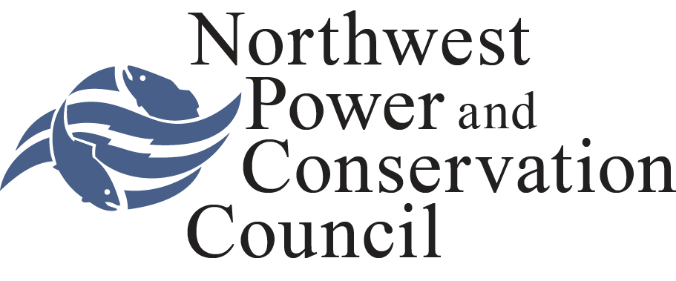 | Jennifer Anders  Vice Chair  Montana
Henry Lorenzen  Oregon  W. Bill Booth  Idaho  James A. Yost  Idaho |  | Pat Smith  Montana  Tom Karier  Washington  Phil Rockefeller  Washington

April 30, 2013

MEMORANDUM

TO: Fish and Wildlife committee members

FROM: Tony Grover

SUBJECT: Sub-agenda for the Fish Tagging Forum presentations to the Committee

The members of the Fish Tagging Forum, the Forum facilitator, an IEAB representative and Council staff will present the results of the Fish Tagging Forum in the following sequence:

- Introductory Remarks by the Forum Chair -- Therese Hampton

- Description of the Forum process, work products and methodologies -- Kevin Kytola, facilitator

- Brief description of background, overview, tagging technologies management questions and indicators -- Kevin Kytola with support of Forum members and Council staff

- Description of the IEAB interim report on Cost-Effectiveness of Fish Tagging Technologies and Programs, Dr. Bill Jaeger (by phone)

- Brief description of Forum recommendations -- Kevin Kytola with support from the Forum chair, Forum members and Council staff

- Individual Forum members presentations:

  - To aid the Council in it's deliberations and decision making surrounding the final recommendations of the Fish Tagging Forum, CRITFC will be providing materials on the necessity of 1) comprehensive catch sampling, 2) representative tagging of fish at Mitchell Act hatcheries, and 3) cost sharing for those activities by Action Agencies. Marianne McClure will briefly summarize the written memo and outline the many uses of CWT data.

  - Guy Norman of the Washington Department of Fish and Wildlife will discuss the Tagging Forum recommendations at the May 7 Fish and Wildlife Committee meeting. Since a consensus on all recommendation on the funding of Coded-Wire-Tag (CWT) activities could not be reached, the Tagging Forum proposed four alternatives to consider in addition to CWT Program consensus recommendations. The Washington Department of Fish and Wildlife is concerned with the consequences of alternatives that include a significant reduction in the scope of the CWT Program, in particular program changes that would affect the region’s ability to collect the necessary data to adequately assess population status, hatchery programs, and fishery conservation. Regional Director Norman’s presentation will focus on the potential consequences of the alternative CWT recommendations to answer key Columbia River salmon and steelhead management questions.

  - Oregon Department of Fish and Wildlife statement

  - Northwest River Partners statement

  - Bonneville Power Administration statement

  - Statements by additional Forum members

- Discussion of recommendations by Fish and Wildlife Committee members with members of the Forum.

________________________________________
c:\users\grover\desktop\ftf committee sub agenda may 2013.docx (Tony Grover)

