Table of Contents
37 San Poil Subbasin Overview 2
37.1 Regional Context for San Poil Subbasin 2
37.2 San Poil Subbasin Description 2
37.3 Logic Path 11

37 San Poil Subbasin Overview

37.1 Regional Context for San Poil Subbasin
The San Poil Subbasin is one of six subbasins that comprise the IMP. The Subbasin is bounded to the west by the Lake Rufus Woods Subbasin and to the east and north by the Upper Columbia Subbasin (Figure 37.1). The major drainage consists primarily of the San Poil River and its tributaries, which are a major tributary to Franklin D. Roosevelt Lake.

37.2 San Poil Subbasin Description

37.2.1 General Location
The San Poil River originates in the Okanogan Highlands east of the Okanogan River and drains in a southerly direction for 27 miles through parts of the Colville and Okanogan National Forests in Ferry and Okanogan counties. The river then enters the Colville Indian Reservation and flows approximately 32 miles south before it enters the impounded Columbia River in the San Poil arm of Lake Roosevelt at river mile 615.5 (Figure 37.1). The resulting reservoir, Lake Roosevelt, inundates 33,490 ha at a full pool elevation of 1,289 ft (msl) (Thatcher et al. 1992). Annual water retention time is less than 40 days (Thatcher et al. 1992).

37.2.2 Drainage
The San Poil drainage forms the Water Resource Inventory Area (WRIA 52) as defined by the WDOE. The Subbasin encompasses approximately 981square miles of Ferry and Okanogan counties (WDOE GIS data), which includes about 500 square miles of Tribal land on the Colville Indian Reservation. Elevations within the Subbasin range from 7,135 feet above sea level at Copper Butte to 1,290 feet for Lake Roosevelt at full pool. Major tributaries to the San Poil River include Bridge, Gold, Granite, Iron, Louie, Lost, Manilla, Ninemile, North Nanamkin, O’Brien, Scatter, Thirteenmile, Seventeenmile, South Nanamkin, Thirtymile, Twentyfive mile, Twentythree mile creeks and the North, South, and West Forks of the San Poil River. Lakes include Crawfish, Ferry, Gold, Swan, and Long lakes. Historically, Curlew Lake had a hydrologic connection to the San Poil River and Subbasin, but anthropogenic alterations eliminated this connection in the early 1900s and since that time all overland flows have been directed to the Kettle River and the Upper Columbia Subbasin. Therefore, Curlew Lake has been placed in the Upper Columbia Subbasin for the purpose of subbasin planning.

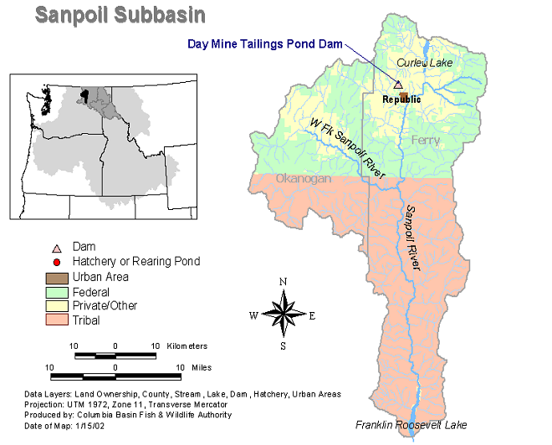

Figure 37.1. San Poil Subbasin (Note: Curlew Lake is part of the Upper Columbia Subbasin)

37.2.3 Climate
The area has a continental climate that is influenced by maritime air masses from the Pacific Coast. This region has an average temperature of 6.6° C (44° F), with the month of July being the warmest and January the coldest. An average of 42.5 cm (16.73 inches) of precipitation falls on the region, with an average of 130 cm (51 inches) of snow (Weather Underground 2003).

37.2.4 Geology
The San Poil Subbasin lies on two geologic provinces. The first is the old coastal plain that at one time was part of the western margin of North America. The coastal plain was shifted into tight folds of sedimentary rock, with granitic intrusions known now as the Kootenay Arc. West of the Kootenay Arc is the Okanogan subcontinent, an island about the size of California, that was pushed up against the Kootenay Arc due to continental drift. The southern portions of both provinces disappear beneath the Miocene basalt flows of the Columbia Plateau to the south (Alt and Hyndman, 1984).

37.2.5 Soils
Soils of the Subbasin are tied to elevation. In high elevation mountain areas, the soils are derived from granite parent material. The texture is a gravelly sandy loam that normally has a depth of a meter or less. These soils also have some volcanic ash, which has a silt loam texture. In lower elevations at the margins of river valleys, soils are derived from glacial till. The texture is normally sandy-loam to loam and moderately dark in color. At the lowest elevation along rivers, the soils are coarse in texture. They are derived from glacial outwash sands and gravels (Franklin and Dyrness 1988).

37.2.6 Vegetation
Historically the landscape was dominated by sub-alpine fir and lodgepole pine in the higher elevations and mosaics of even-aged, relatively open stands of fire resistant ponderosa pine in the lower elevations (CCT 2000). The higher elevations were frequently burned before fire suppression began in 1930 (CCT 2000). Fire suppression changed the forest composition by removing the natural force for thinning the forest, increasing the forest density, and favoring conditions for multiple canopy stands (CCT 2000).

Figure 37.2 shows the current distribution of wildlife-habitat types in the San Poil Subbasin based on IBIS (2003). Currently, the native vegetation is predominated by pine savannas with grasses, shrubs, and ponderosa pine trees in low elevations of the Subbasin. As these areas transition into higher elevations with increased precipitation, communities of Douglas fir/ponderosa pine/larch and red cedar/hemlock become dominant (CCT 2000). Agricultural lands comprise less than one percent of the total area within the Subbasin. Urbanization is limited within the Subbasin; the town of Republic is the largest urban center in the Subbasin.
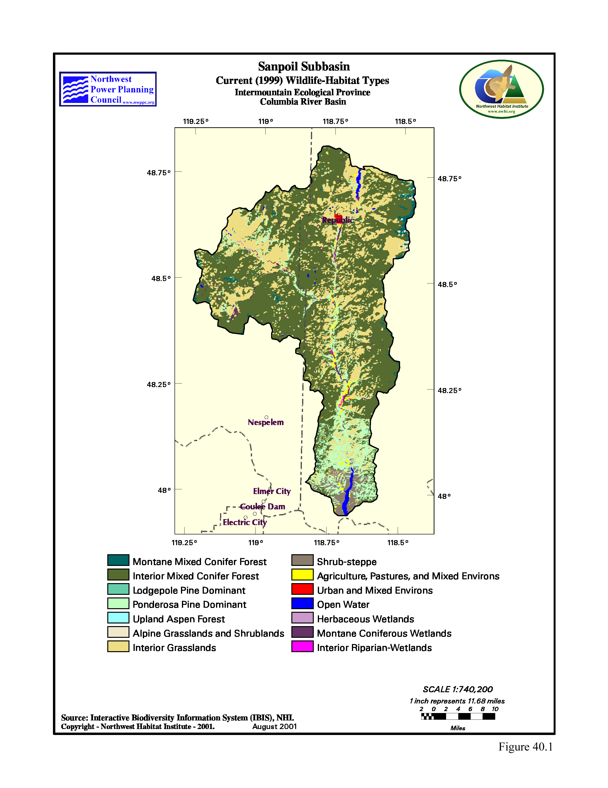
Figure 37.2. Habitat types found in the San Poil Subbasin, taken from IBIS (2003)

Major Land Uses
Figure 37.1 shows the major land ownership categories in the San Poil Subbasin. The primary land uses in this Subbasin are agriculture, grazing, logging, and mining. Cattle grazing is present throughout contributing to soil compaction, increased stream width-to-depth ratios, and displacement of native wildlife species (Council 2000). The Subbasin is heavily forested with many areas of timber harvest and associated roads present on Colville Indian Reservation lands, Colville National Forest Lands, and private lands. On a much smaller scale, urban development (towns of Republic and Keller) has also occurred.

The building of State Highway 21 effectively blocked fish access to a majority of the streams entering the west side of San Poil River due to poorly designed or improperly installed culverts (John Arterburn, Fish Biologist, CCT, personal communication, 2003). Access was maintained into the West Fork of the San Poil River because a bridge was installed. In addition, Scatter Creek, which enters the San Poil River from the west, has no access problems for fish entering it from the San Poil River. A review of aerial photographs from 1946, 1966, 1973, 1983, and 1991 indicates a progressive deterioration of in-stream and floodplain conditions. By 1946, most highways had been established providing access to this area; these main roads were likely established to bring materials and supplies to the Grand Coulee area during construction of Grand Coulee Dam.

The San Poil River was a single defined channel with a broad floodplain and heavy canopy cover made up of mature trees. In the period from 1946 to 1966 profound changes had occurred within the floodplain areas from clearing land for timber and for cultivation. The San Poil River begins to show signs of lateral scouring. Major impacts were evident to both the San Poil River and Bridge Creek system in the 1966 to 1973 photos, including an almost complete deforestation of the Bridge Creek riparian corridor and a change from the stable meandering course to a well-incised straight form (Wilber et al. 2002). By 1973, the floodplain of the San Poil River was almost completely deforested, bank erosion was evident along many reaches, large sand bars were prevalent, and the channel was considerably straighter (Wilber et al. 2002). By 1983 channel width had increased by four to five times historic with expansive sand flats indicating a system that is overloaded with sediments and a channel that is in disequilibrium. Within the last two decades conditions along the San Poil River have stabilized with some minor improvements but channel width is still approximately four times historic, riparian areas are largely denuded, and sediment loads are still higher than the river can effectively convey (John Arterburn, Fish Biologist, CCT, personal communication, 2003).

Figure 37.3 shows road density, by density class, for each sixth order watershed in the San Poil Subbasin. Nearly the entire Subbasin is ranked as high road density (1.7 to 4.7 miles of road per square mile). One watershed at the southern end of the Subbasin ranked as moderate road density (0.7 to 1.7 miles of road per square mile). No watersheds in the Subbasin are ranked as low or very low for road density. The highest road densities on the Colville Reservation are located in the Strawberry Creek, Lime Creek, King Creek, Upper Gold Creek, and south fork of Lost Creek drainages in the west fork of the San Poil River watershed. The highest road densities along the mainstem San Poil River include Cache, Meadow, and Capoose creeks along with the upper portion of the inundated section. The number of road crossing was highest in the upper Gold Creek, Manila Creek, Bridge Creek, 30-mile Creek, and along mainstem San Poil River. All these areas had more than 25 crossings within the respective watershed management unit; these known road densities and crossing numbers are likely to be underestimated (CCT 2000).

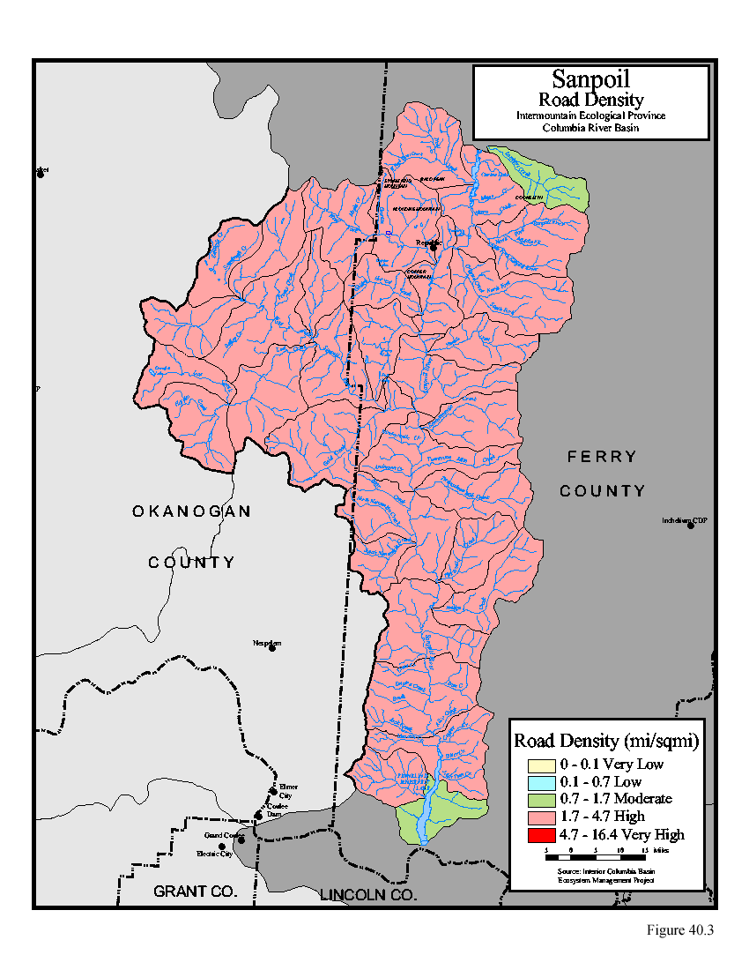
Figure 37.3. Road density for sixth order watersheds in the San Poil Subbasin

37.2.8 Lake Roosevelt Shoreline Erosion
Construction of Grand Coulee Dam resulted in inundation of the lowermost 12 miles of the San Poil River. Overall, about 70 percent of the Lake Roosevelt shoreline consists of easily eroded unconsolidated sediments (USBR 2000). The sediments are alternately exposed during winter reservoir drawdowns, and inundated during full pool operation. The combination of wave action and water fluctuations has contributed to slope failures of these inherently unstable soils at many locations around the reservoir. Figure 37.4 shows the portion of Lake Roosevelt located within the San Poil Subbasin and highlights the areas of high erosion potential along the shoreline. Analysis of a 300-foot band upslope of the 1,290-foot elevation level shows that 38 percent of the area within the band has high erosion potential, while about 8 percent is composed of bedrock. Soils in the San Poil River watershed are predominately erodible types and once exposed are easily dislodged and do not contain enough nutrients for vegetation to colonize rapidly. Therefore, fine sediment issues are a major problem throughout the San Poil Subbasin.

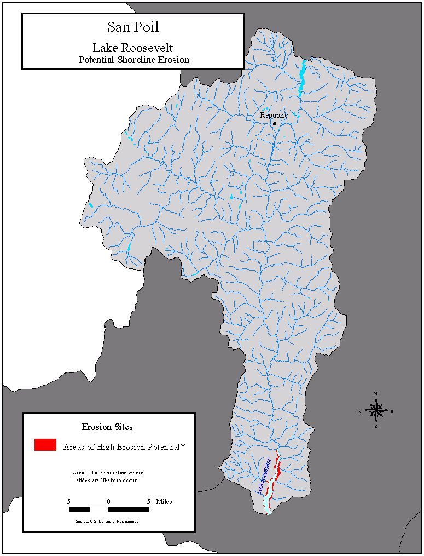
Figure 37.4. Areas of high erosion potential for areas of Lake Roosevelt located in the San Poil Subbasin. Note: areas of high erosion potential emphasized for display purposes, and are not to scale.

37.3 Logic Path
The logic path starts with an overall physical description of the Subbasin, followed by an assessment of aquatic and terrestrial resources from which a management plan was created with specific strategies and objectives to address limiting factors and management goals. In the next section, Section 38: Aquatic Assessment San Poil Subbasin, aquatic resources regarding the historic and current status of selected focal species are described in detail. An analysis based on the QHA technique (described in Section 3) identifies specific habitat attributes that have been altered the most over time relative to the entire Subbasin and which areas in the Subbasin are categorized as having poor or good habitat for the respective focal species. Based on the current status of the focal species, limiting habitat attributes, and management goals recognized in the Subbasin, strategies and objectives were identified and are presented in Section 42: San Poil Subbasin Management Plan. The terrestrial assessment, provided in Section 40, provides a description of the historic and current status of wildlife species and condition of terrestrial habitat types within the Subbasin. Based on the terrestrial assessment and key findings, strategies and objectives were developed and are defined in Section 40: San Poil Subbasin Management Plan.

Portions of Section 37.2 were contributed to by the San Poil Subbasin Summary Report (2000) pp. 1-3.

