W. Bill Booth  Chair  Idaho | 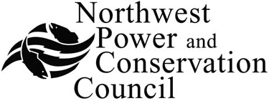 | Bruce A. Measure  Vice-Chair  Montana
James A. Yost  Idaho  Tom Karier  Washington  Dick Wallace  Washington |  | Rhonda Whiting  Montana  Melinda S. Eden  Oregon  Joan M. Dukes  Oregon
Wildlife Crediting Forum
Council Central Offices – Fifth Floor Conference Room
851 S.W. Sixth Avenue, Suite 1100, Portland, Oregon 97204
503-222-5161
February 17, 2010 – 8:00 a.m. to 2:00 p.m.
Call-in: 800-786-1922, Guest Code: 33748659
GoToMeeting: To access GoToMeeting use the following link: https://www1.gotomeeting.com/join/733686553
Access Code - 33748659

 | 8:00 a.m. | Welcome Statements: Forum Management Officer & Chair
2. | 8:15 a.m. | Program Background and History – Peter Paquet
3. | 9:00 a.m. | HEP – As Designed, As Used, As Evolved – Paul Ashley
4. | 10:00 a.m. | Break
5. | 10:15 a.m. | New Approaches – Beyond HEP – Don Steffeck
6. | 11:00 a.m. | New and Improved Crediting Ledger - BPA
7. | 11:45 a.m. | Lunch Break
8. | 12:30 p.m. | Crediting Ledger – Part 2 - BPA
9. | 1:00 p.m. | Preliminary Discussion on Gaining Consensus on Ledger - All
10. | 1:45 p.m. | March Meeting Agenda and Goals - All

