W. Bill Booth  Chair  Idaho | 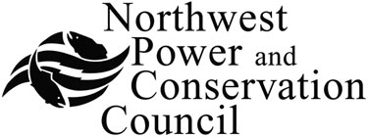 | Bruce A. Measure  Vice-Chair  Montana
James A. Yost  Idaho  Tom Karier  Washington  Dick Wallace  Washington |  | Rhonda Whiting  Montana  Melinda S. Eden  Oregon  Joan M. Dukes  Oregon

Draft Agenda for the Second Meeting of Demand Forecast Advisory Committee
June 27th 2008
Address for the Meeting. Same building as the Council's offices but on the 3rd floor
Columbia Basin Fish and Wildlife Association (CBFWA)
851 SW Sixth Avenue, Suite 300

Greetings and introduction of new members 10:00 am
Review of agenda
Discussion of Council’s planning process
A brief over-view of Council’s long-term Demand model

Discussion of Economic Drivers
- Fuel Price Forecast ( Medium and High price forecasts)
- Inflation rate
- Residential Sector
- Commercial Sector
- Industrial Sector
- Transportation sector

Discussion of Preliminary Electricity Forecast
- Residential Sector
- Commercial Sector ( hidden data centers)
- Industrial Sector ( DSI, custom data centers and refrigerated warehouses)
- Transportation sector ( plug-in hybrids)

Discussion of Other items: 2:00-2:45
- Enduse Load-shapes
- Treatment of Conservation achievements (Charlie Grist)
- Brief overview of the portfolio model (Michael Schilmoeller)
Next steps: 2:45 - 3:00
- Update to economic forecast (October 2008)
- Integration of demand and supply modules

Note: We will have a working lunch. You can order lunch by following this link.
Lunch from Espress-O Deli http://www.nwcouncil.org/forms/deli.asp
(Please have lunch ordered by NOON on June 26)

