Nancy-

Here are some thoughts- I’ll also be curious to see what comes up in tomorrow’s call…

This is going to need a lot of development before it can become a framework- be it skeleton we can attach muscles to to do real work, or Xmas tree that can support ornaments. Right now its more of a chalk outline of a body. Don’t get me wrong- that’s a start. I’ve got a few edits/comments in the text, and look forward to seeing future iterations.

What I’d hope to see is a framework that lays out:

- how the Council and partners can clearly articulate what RME questions are/need to be address,
- how program investments can be guided to addressing those questions in a coordinated, strategic manner (but not a top down prescriptive manner), and
- how results can be compiled and assessed into summations of the state of knowledge for key ?s
- how rigorous adaptive management loops can be built to encourage project sponsors to adjust their on-the-ground actions in response to improving knowledge

I see key tools the Council and partners can bring to bear as:

The scientific review process (ISRP, NOAA RIST, etc)- what is used to review topic areas and identify key ?s, and then periodically produce state of the knowledge reports?

The structuring of project solicitations- forcing both RME and action projects to place themselves in the context of the ?s that affect their work

I’d want to see a framework that is explicit about how these types of tools are used.

Framework must be scalable so council members can look at a one page diagram of major focal areas, but others can drill into competing hypothesis or specific questions, and how we might answer them and apply results to specific project types…

Framework must be relational so that we can capture the fact that one project may address many questions, and that one question may be addressed by many projects. Right now Bruce’s tables fail to make any link between projects and questions asked…

Thinking about this has made me search my bookcase for my missing copy of Compass and Gyroscope… It’d be a good book to revisit now.

Enough, enough, for it is late (making up for that delightful nap earlier in the evening…)

Alex

Columbia River Basin Salmonid Monitoring Sub-Framework

As partners in the Columbia Basin protect, mitigate, and restore fish and wildlife, a Columbia Basin-wide monitoring framework that can assist in linking local management questions is essential. This framework will guide development and implementation of monitoring programs and regional/subregional monitoring strategies. While the framework is intended to provide guidance for as many programs as possible, not all actions in the Basin will necessarily conform, nor will they need to if their funding is independent of the partners using this framework. It is important, whether or not the same framework is used, that these other programs continue to communicate, exchange data, and collaborate as feasible with other Columbia Basin Program.

Intro needs punch- just a quick go at what I mean:

The Columbia Basin is the focus of one of the largest and most expensive ecosystem restoration programs in the world. Since 198?, the BPA-funded Fish and Wildlife Program has invested over $?? (just direct program to avoid battles) on efforts to improve anadromous fish runs. Tributary and estuary habitat is being restored, passage conditions in the Columbia are being improved, hatcheries are rebuilding some fish runs while supporting harvest, and undesired predation is being reduced. All of these funded actions are being done in an ecologically complex setting, and there are significant uncertainties that need to be address to ensure that resources are being used effectively to meet anadromous fish restoration goals. The Fish and Wildlife program and partners in the Columbia Basin have addressed these uncertainties by committing over $100 million per year to research and monitoring efforts. This document proposes a framework that can be used to 1) track and coordinate the questions that these efforts are asking, and 2) ensure that results of these efforts to address uncertainties are compiled and used to improve restoration actions undertaken as part of the Fish and Wildlife program.

How does the salmonid sub-framework relate to a Basin-wide monitoring framework?
The salmonid sub-framework is just a component of a larger monitoring framework for the monitoring of anadromous and resident fish and wildlife in the Columbia River Basin. Managing, exchanging, and evaluating the monitoring data collected and reporting findings, although not included at this time, are important aspects that need to be addressed to facilitate adaptive management and to inform decision-makers. These broader components of the framework will be formulated during subsequent steps.

The basin-wide framework establishes minimum scientific standards or guidelines for each sub-framework (e.g., salmonid monitoring) that each local monitoring strategy must have in common. These minimum standards are intended to ensure that local strategies implementing components of this broader framework are designed to:
- address shared management questions;
- estimate the standard evaluation indicators necessary to answer these shared management questions, and
- produce indicators capable of being integrated/aggregated to address management questions at larger scales.

The basin-wide framework establishes general standards for each category of monitoring information, while not being prescriptive so as to allow local strategies to reflect local geographic, ecological, and biological constraints and also be respectful of local partners’ unique values, goals and responsibilities. The framework is the over-arching design that allows strategies to fully meet local monitoring needs while contributing effectively and efficiently to a comprehensive basin-wide monitoring and adaptive management plan.

The intent of articulating this basin-wide framework is to assist in identifying and filling gaps necessary to standardize and integrate local monitoring strategies. Understanding that available resources to fill a basin-wide framework are limited, we also propose criteria to inform prioritization of locally identified gaps at the basin-wide scale. These are accomplished by applying a standard format with consistent elements to describe current monitoring programs/strategies, as well as to encourage conformance in future programs/strategies.

Framework Definitions
Framework: the standard basin-wide monitoring structure and approach which guides all local monitoring strategies
Strategy: the local approach for implementing components of the framework as dictated by local environmental/geographic constraints, biology, etc. A strategy needs to be shared across federal/state/tribal/entities in a local sub-region or domain.
Programs: are coordinated collections of projects designed to implement the local strategy. Programs may represent comprehensive portfolios of integrated projects implemented by several agencies in partnership, or by one agency alone.

Framework Description
Framework Categories: Each sub-framework of the basin-wide framework is organized around six broad categories of monitoring information: species, habitat, harvest, artificial production, hydropower, and disease/predation (see Figure 1). Each of these monitoring categories must include status and trend, project implementation and compliance, and action effectiveness monitoring components that support management questions and decisions (please see footnote requesting specific feedback on these categories).

Clearly, not all species’ monitoring in the Columbia River Basin (anadromous fish, resident fish, and wildlife) will utilize all monitoring categories.

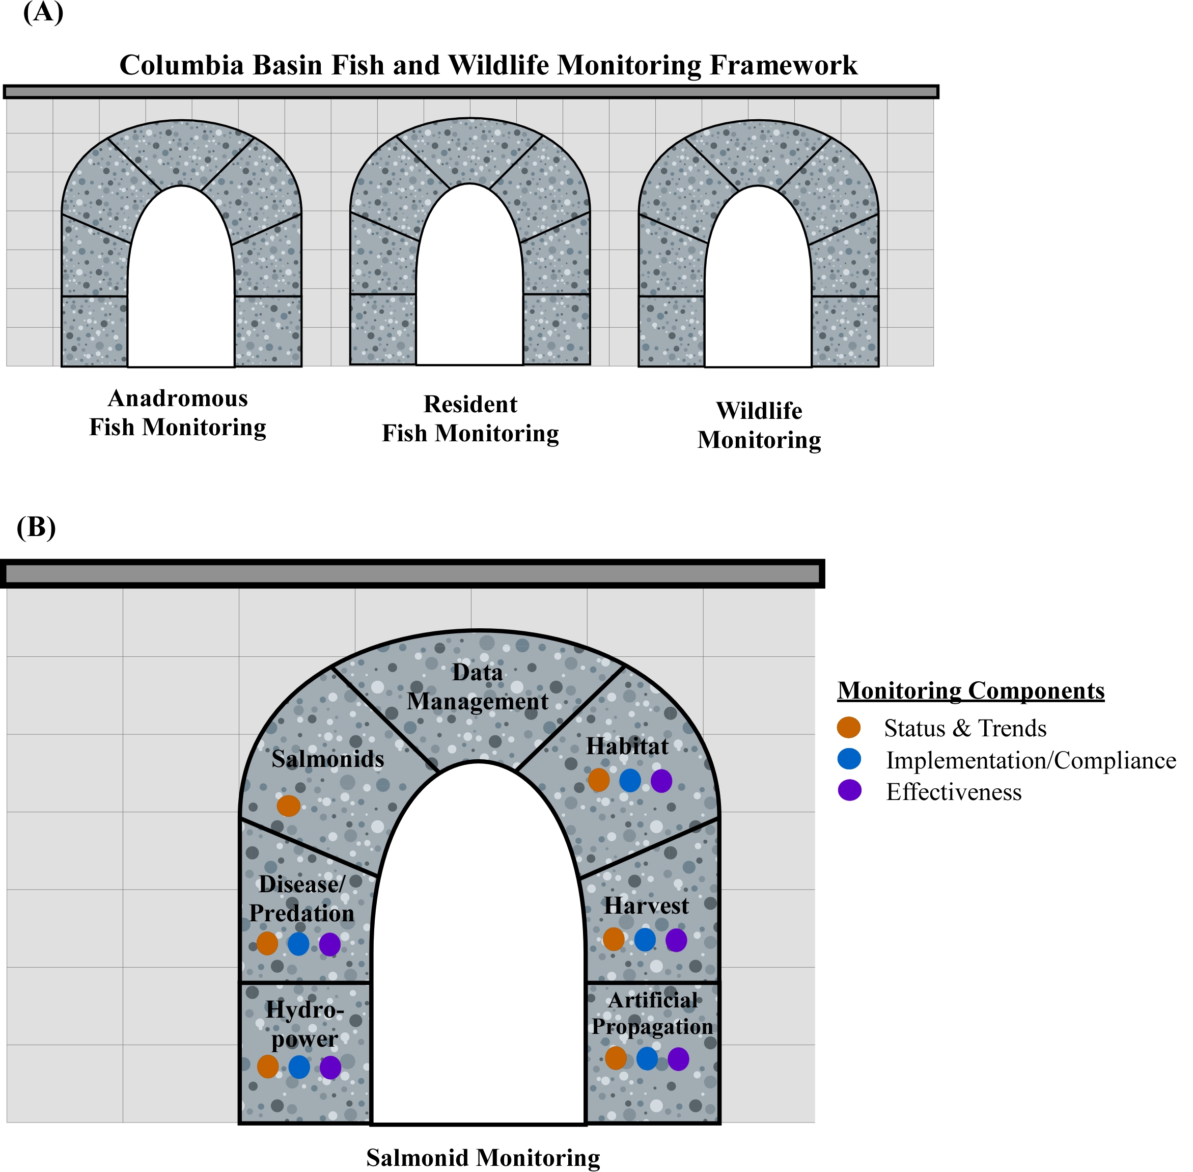
Figure 1. (A) Diagram of a comprehensive Columbia Basin monitoring “framework” including monitoring for anadromous fish, resident fish, and wildlife. (B) Diagram of the salmonid monitoring sub-framework depicting the 5 monitoring categories (species, habitat, disease/predation, harvest, hydropower, and artificial production) each including status and trend, implementation/compliance, and effectiveness monitoring components.

Framework Elements: The framework uses a standard set of four elements to ensure all local monitoring strategies are coordinated and consistent. These elements are:

- What is(are) the higher level management question(s) the monitoring each local strategy supports?
- What indicators will local monitoring strategies inform that contribute towards answering the stated management questions?
- What are the “standards” that each local strategy must meet?
- What are important criteria by which funding priorities may be set?

How would the framework look applied to salmonid monitoring?
The current process to develop a consensus monitoring framework and integrated sub-regional strategies for anadromous fish in the Columbia River Basin is confined to the salmonid status and trend monitoring, artificial production effectiveness monitoring, and habitat effectiveness categories (see Figure 2). Nonetheless, it is important to recognize the monitoring categories we are addressing are but a subset of a comprehensive and coordinated monitoring framework for anadromous fish species, that fits within an even broader monitoring framework for anadromous and resident fish and wildlife species in the Columbia Basin.

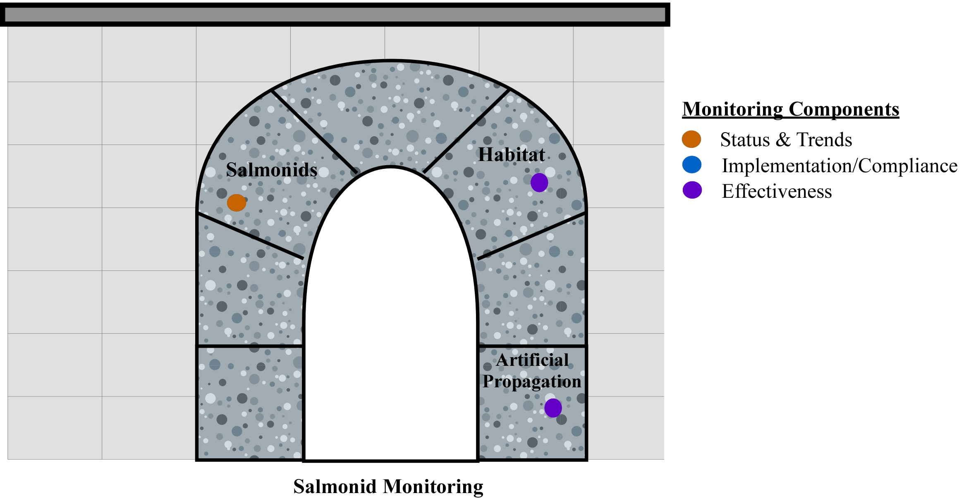
Figure 2. Diagram of the salmonid monitoring sub-framework depicting the monitoring categories being addressed in the current collaborative process relative to the entire sub-framework shown in Figure 1(B): salmonid status and trend; artificial production effectiveness; and habitat effectiveness.

Within the subset of monitoring categories we are presently addressing for anadromous fish monitoring, there are a variety of evaluation needs that must utilize the monitoring information collected through the framework (see examples Table 1). These evaluation needs differ in the depth and breadth of their monitoring information requirements. However, the overall anadromous species framework represents an integrated and coordinated collection of local strategies intended to fully support each of these evaluation needs.

Table 1: Utilization of monitoring categories by different evaluation needs for salmonid monitoring in the Columbia River Basin.
Examples of Evaluation Needs (Monitoring programs) | Category  [monitoring components within categories:  S&T = status and trends; I/C = implementation and compliance; E = Effectiveness]
 | Salmonids | Disease/  Predation |  |  | Habitat |  |  | Harvest |  |  |  | Artificial Production |  |  | Hydro-power
 | S&T | S&T | I/C | E | S&T | I/C | E | S&T | I/C | E | S&T |  | I/C | E | S&T | I/C | E
Recovery Plans
Biological Opinions:
a) FCRPS
i) RPAs
ii) AMIP
NPCC Fish and Wildlife Program
others

Salmonid Sub-Framework Prioritization:

(please see footnote requesting specific feedback on prioritization )

The following pages illustrate the salmonid sub-framework as applied to four VSP criteria, hatchery effectiveness, and habitat effectiveness.

VSP Criteria Monitoring Sub-Framework – ABUNDANCE

MANAGEMENT QUESTIONS  - What is the abundance of anadromous fish in the Columbia River Basin?  - What is the population-level natural spawner abundance relative to TRT viability criteria or recovery plan goals?  - What is the variance in population-level adult abundance estimates? | INDICATORS  - Number of hatchery- and natural-origin spawners  - Hatchery- and natural-origin escapement  - Coefficient of variation
STANDARDS
- High precision annual adult status and trend data for at least one population per MPG (high-precision monitoring should be invested in TRT “must have” or recovery plan “high priority” populations first)
- Lower precision annual adult status and trend data of known certainty and power for every population
- The proportion of hatchery-origin fish must be monitored for all populations
- Adult monitoring should utilize standardized methods and procedures that permit the aggregation of estimated population-level abundance (and certainty levels) at greater spatial scales (e.g., MPG and ESU/DPS)

PRIORITIZATION CRITERIA
- –Fill gaps where a MPG lacks high-precision monitoring for at least one –
–High precision monitoring should be invested in TRT “must have” or recovery plan “high priority” populations first
- –Ensure, at a minimum, lower precision monitoring of known certainty exists for every population
–Gaps in lower precision monitoring should be filled first for TRT “must have” populations, then for TRT “optional must-have” populations, and lastly for TRT “maintenance” or “sustaining” populations
- -Improvements to existing lower precision monitoring by should be implemented first for populations that are closest to contingency triggers (e.g., FCRPS adaptive Management Implementation Plan) or furthest from established viability targets/recovery goals.

VSP Criteria Monitoring Sub-Framework – PRODUCTIVTY

MANAGEMENT QUESTIONS  - What is the abundance of anadromous fish in the Columbia River Basin?  - What is the status and trend in population-level adult:adult productivity relative to TRT viability criteria or recovery plan goals?  - What is the status and trend of population-level smolt:adult productivity?  - What is the variance about adult and smolt productivity estimates? | INDICATORS  - Adult:adult  - Lambda  - Smolt:Adult  - Coefficient of variation
STANDARDS
- Annual estimates of adult:adult productivity of known certainty for each population
- Annual estimates of juvenile migrants of known certainty and power for at least one population per MPG. Monitoring of juvenile production should be conducted for populations with high-precision adult monitoring.
- Juvenile monitoring should utilize standardized methods and procedures that permit the aggregation of population-level estimates (and certainty levels) at greater spatial scales (e.g., MPG and ESU/DPS) where available and appropriate.

PRIORITIZATION CRITERIA
- –Fill gaps where a MPG lacks juvenile monitoring paired with high-precision adult monitoring for at least one MPG
–Paired adult and juvenile monitoring should be invested in TRT “must have” or recovery plan “high priority” populations first
- –Implement improvements to existing juvenile monitoring to improve estimates at the population-scale and/or to improve certainty and power to necessary levels
- Expand juvenile monitoring to more than one population per MPG for those populations with higher survival and recovery gaps.

VSP Criteria Monitoring Sub-Framework – SPATIAL STRUCTURE

MANAGEMENT QUESTIONS  - Has there been a change in the spawning distribution within populations?  - Has there been a change in the relative distribution natural production across populations within an MPG?  - Has there been a changed in the connectivity among populations within an MPG  - What is the variance about the estimate of spawning distribution? | INDICATORS  - Number and distribution of spawner areas  - Change in spawner density and distribution  - Change in juvenile density and distribution  - Coefficient of variation
STANDARDS
- Periodic surveys of adult and juvenile density and distribution at the population and/or MPG scale.
- Monitoring of spatial distribution should utilize standardized methods and procedures (e.g., total census or probabilistic sampling) that permit the evaluation of changes in distribution at the population and MPG scales and the estimation of precision.

PRIORITIZATION CRITERIA
- –Fill gaps where an MPG lacks any periodic spatial distribution monitoring (at the population or MPG scale).
- –Expand/add/improve spatial distribution monitoring particularly for populations where the improvement or removal of passage barriers is a key component of the recovery strategy.

VSP Criteria Monitoring Sub-Framework – DIVERSITY

MANAGEMENT QUESTIONS  - Has there been a change in the genetic or phenotypic diversity of the species at the population, MPG, or ESU scales? | INDICATORS  - Genetic diversity (e.g., F_{ST})  - Juvenile/adult migration timing  - Spawn timing  - Age distribution  - Age at maturity  - Fecundity  - Sex ratio
STANDARDS
- Periodic sampling of population genetic diversity (e.g., based on single nucleotide polymorphisms (SNPs))
- Periodic monitoring of population phenotypic diversity (e.g., juvenile outmigration timing, adult run timing, spawn timing, age distribution, age at maturity, fecundity, sex ratio).

PRIORITIZATION CRITERIA
- –Initiate population genetic/phenotypic diversity monitoring where baseline information does not exist.
- –Expand/add/improve population diversity monitoring for populations where threats to diversity (e.g., hatchery introgression, climate change) are prominent factors limiting recovery.

Artificial Production Effectiveness Monitoring Sub-Framework

MANAGEMENT QUESTIONS  - Are artificial production programs successful in meeting their implementation and biological performance objectives, such as juvenile release and adult harvest goals?  - Have artificial production strategies been effective in maintaining or improving the ecological processes, phenotypic and genetic characteristics, and reproductive fitness of natural populations?  - Are artificial production programs effective in reducing the ratio of hatchery-origin spawners through the use of harvest, weirs, or a mixture of techniques?  - Can properly designed intervention programs using artificial production make a net positive contribution to recovery of listed populations?  - What is the reproductive success of hatchery fish spawning in the wild relative to the reproductive success of wild fish? | INDICATORS  - Number of hatchery- and natural-origin spawners  - Hatchery- and natural-origin escapement  - Hatchery- and natural-origin lambda  - Genetic and phenotypic indicators  - Stray rates
STANDARDS
- The relative proportion of natural- and hatchery-origin spawners must be determinable through 100% marking of hatchery releases (e.g., through external marking, tagging, or other means).
- The genotypic and phenotypic characteristics of the hatchery broodstock and any local natural populations must be periodically monitored.
- Artificial production programs that produce fish that spawn with natural-origin fish must monitor their relative reproductive success.

PRIORITIZATION CRITERIA
- – Add artificial production effectiveness monitoring studies to ensure a sufficiently diverse representation of program types, eco-geographical distribution, and propagated species to inform future adaptive management.

Habitat Effectiveness Monitoring Sub-Framework

MANAGEMENT QUESTIONS  - Have habitat restoration actions been effective in improving habitat condition?  - Have habitat restoration actions been effective in improving fish status, productivity, and/or distribution?  - What are the expected cumulative benefits of multiple habitat restoration actions on population abundance, productivity and survival?  - What are the habitat limiting factors or threats preventing the achievement of desired habitat performance objectives? | INDICATORS  - Habitat condition indicators  - Smolt:Adult
STANDARDS
- Implement BACI experimental design studies in watersheds where sufficient habitat restoration actions may be effectively implemented and monitored to effect a detectable change in monitored fish status (high precision adult abundance and smolt production) and habitat response indicators.
- The implementation of all regional and local restoration efforts should be reported and monitored using consistent implementation tracking metrics (e.g., PISCES implementation of RPA 73, PCSRF database).
- Implement at least one intensively monitored watershed (IMW) for each domain and address different limiting factors by coordinating IMW sites and designs across the Pacific Northwest
PRIORITIZATION CRITERIA
- –Implement habitat effectiveness monitoring studies where there is commitment by funding entities to fully implement restoration actions over a short period such that fish and habitat response may be detected.
- –Add habitat effectiveness monitoring studies to ensure a sufficiently diverse representation of treatment types, eco-geographical distribution, target species and life stages, and limiting factors addressed to inform habitat modeling efforts and adaptive management.

Should these monitoring components also include critical uncertainties research? ABSOLUTELY! FOCUS SHOULD BE ON ?S ASKED AND HOW WE GET ANSWERS- SO FAR THE MONITORING DISCUSSION HAS SHIED AWAY FROM THE RESEARCH COMPONENT, EVEN THOUGHT IT IS AHUGE PART OF THE $ TOTALS WE AR ELOOKING ATThe Planning team commenters noted that critical uncertainties research are large components of monitoring programs in the basin, part of the BiOp and AMIP, and part of current project-prioritization exercise, and felt that the framework must include this work.
For the time being, this section – proposing criteria for prioritizing among monitoring gaps across sub-regions – has been removed. This will be an item of considerable discussion at the November workshop. However, your suggestions for prioritization criteria would be welcome.

