Bill Bradbury  Chair  Oregon | 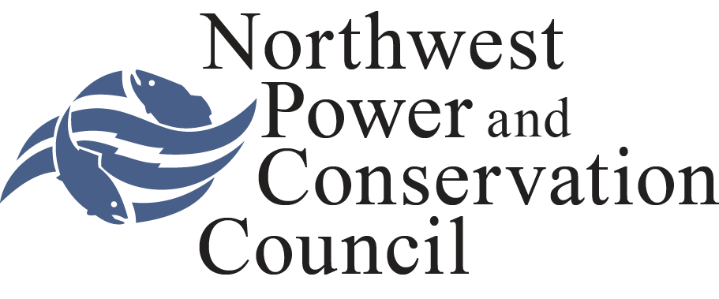 | Jennifer Anders  Vice Chair  Montana
Henry Lorenzen  Oregon  W. Bill Booth  Idaho  James A. Yost  Idaho |  | Pat Smith  Montana  Tom Karier  Washington  Phil Rockefeller  Washington

NORTHWEST POWER AND CONSERVATION COUNCIL

CHARTER OF THE

OCEAN AND PLUME SCIENCE AND MANAGEMENT FORUM

- Official Designation: This Forum will be known as the Northwest Power and Conservation Council's Ocean and Plume Science and Management Forum.

- Background: In 2010 the Council reviewed all Research, Monitoring and Evaluation projects, and requested that an Ocean Synthesis Report be developed by three ocean project sponsors. After ISRP review of this report the Council decided to re-focus the ocean research program and hosted an Ocean and Plume Workshop to explore future opportunities for research. This workshop was successful at providing a forum for ocean researchers and in-river managers to identify critical uncertainties and potential management applications. To continue regional coordination on ocean research the Council’s Fish and Wildlife Committee requested the development of an Ocean and Plume Science and Management Forum (Forum) charter.

The Council’s Fish and Wildlife Program acknowledges that the ocean, plume and estuary are integral components of the Columbia River ecosystem and the lifecycle of Columbia River salmon. The 2009 Fish and Wildlife Program states the following primary ocean strategy: “Identify the effect of ocean conditions on anadromous fish survival and use this information to evaluate and adjust inland actions (pg. 31).” With this strategy in mind, the goal of this Forum is to engage researchers and fisheries managers in a process of identifying a) the management implications of ocean research and b) priorities for future ocean research. The Forum is expected to produce a list of priority critical uncertainties with clear and measureable hypotheses which can be reflected in the Council’s Research plan and considered for funding by Bonneville.

This advisory committee is established as part of a network of advisory committees satisfying the Council’s obligation under the Act to establish a Scientific and Statistical Advisory Committee. Section 4(c)(11). Under Section 4(a)(4) of the Act, the terms of the Federal Advisory Committee Act, 5 U.S.C. Appendix I, Sections 1-14, apply “to the extent appropriate” to the Council’s advisory committees.

- Objectives and Scope of Activity: The Forum will assist and advise the Council by completing the following tasks:

- Identify key information needs. These needs may be revisited and refined over time, and may include a balance of ocean-related research, monitoring and evaluation tasks.
  - Compile, identify and/or develop management questions related to the implementation of the NW Power Act and the Council’s Fish and Wildlife Program.
  - Identify what research and monitoring has already been done that address the management questions, and what is being done now.

- Identify the critical uncertainties that must be addressed to answer management questions.
- Identify studies to address key uncertainties related to management questions (including duration of study).
- Identify any gaps in studies to address management questions.
- Develop and recommend to the Council a prioritized list of studies to address the management questions to inform future needs. The forum will identify an explicit process to achieve this task.

- Identify and provide opportunities for information sharing between ocean and plume researchers and estuary and freshwater managers.
  - Identify opportunities to disseminate and integrate ocean research information within existing management forums and information channels
  - Develop an integrated, multidisciplinary team approach, include opportunities for multidisciplinary analyses.

- Identify management applications of ocean and plume information, including existing and yet to be collected information. This should include harvest impacts on the Columbia River Basin ecosystem.
  - Make recommendations to the Council on ways to improve the utility and in-river freshwater resource management benefits of both ongoing and proposed ocean and plume research conducted under the Program.
  - Prepare a final report summarizing the recommendations and accomplishments of the forum. This report will be prepared by Council staff and provided to the Council.

- Official to Whom the Ocean and Plume Science and Management Forum Reports: The Ocean and Plume Science and Management Forum will report to the Executive Director of the Council.

- Authority of the Forum: The Forum will serve in an advisory capacity only. Neither the Forum nor its members are authorized to make statements or commitments on behalf of the Council. Non-staff members of the Committee are not Council employees.

- Estimated Annual Operating Costs in Dollars and Person-Days: Three months of staff time per year to organize and attend Forum meetings.

- Forum Members: The Chair of the Forum, in consultation with the Director of the Fish and Wildlife Division, will solicit technical experts to participate on the advisory committee from a wide range of regional stakeholders. The Council’s Executive Director shall approve the participants and, in doing so, shall ensure that membership of the advisory committee is fairly balanced in terms of the points of view represented and the functions to be performed by the advisory committee. Committee members shall be selected based primarily on their technical and policy expertise and experience. Members may include representatives of state and federal fish and wildlife agencies, tribes, Bonneville, customer representatives, universities, public interest groups, and the general public. All Committee members serve at the pleasure of the Council.

- Forum Management Officer: The Forum Management Officer (``Management Officer'') for the Ocean Plume Science and Management Forum will be the Director of the Council's Division of Fish and Wildlife. The Management Officer will designate members of the Council's staff to coordinate and attend meetings of the Forum.

- Chair:
- The Chair of the Council will select the Chair of the Ocean Plume Science and Management Forum from among the members of the Council’s Fish and Wildlife Committee.

- The Forum Chair may be called upon to report to the Executive Director of the Council on appropriate matters, including progress on the tasks described in Part 3 of this Charter.

- The duties of the Forum Chair will include presiding over the Forum meetings, ensuring that detailed minutes of such meetings are prepared and submitted to the Executive Director of the Council in a timely manner, and maintaining communication between the Forum and the Council's staff.

- The Forum Chair will certify detailed minutes of meetings of the Forum. The minutes should include a complete and accurate description of matters discussed, conclusions reached, actions taken, persons invited to meet with the Forum, and persons in attendance. The minutes also will include copies of reports received, issued or approved by the Committee. Minutes of meetings will be prepared and released within ten days of the meeting, unless the Management Officer grants an extension. The Chair will distribute copies of the minutes to members of the Committee and other interested persons.

- Subcommittees or small workgroups of the Forum may be established by the Chair of the Forum to undertake particular aspects of the Forum’s work. Methods for organizing the work and procedures of the Forum must follow the scope of responsibilities assigned to the Forum by the Council. Council staff will make arrangements for Forum meetings and provide general support services.

- Vice-Chair:

  - Vice-Chair of the Ocean and Plume Research and Management Forum
will be selected by the Forum members.

  - The Vice-Chair will perform the duties of the Chair of the Forum in the absence of that Chair, and such other duties as the Chair of the Forum may assign.

- Rules: The Advisory Committee rules approved and adopted by the Council on March 17, 1982, as amended from time to time, will apply to the Ocean and Plume Research and Management Forum to the extent such matters are not covered in this Charter.

Estimated Frequency of Forum Meetings: The Chair of the Forum, after consultation with the Management Officer, or his designee, will call meetings as necessary. The estimated frequency of meetings is quarterly. More frequent meetings may be required initially.

- All meetings will be open to the public, unless closed pursuant to 5 U.S.C. 552b(c). Timely notice of meetings, including agendas, will be made. Interested persons may attend Forum meetings and appear before or file statements with the Forum, subject to such reasonable rules as the Council may prescribe.

- Duration: The Forum will terminate two years from the filing date of this Charter, unless renewed in accordance with the Federal Advisory Committee Act. All Members of the Forum serve at the pleasure of the Council.

This Charter for the Ocean and Plume Research and Management Forum was approved and adopted at a duly noticed meeting of the Northwest Power and Conservation Council, August 7, 2013 in Bend, Oregon.

PACIFIC NORTHWEST ELECTRIC POWER

AND CONSERVATION PLANNING COUNCIL

By: /s/ Bill Bradbury ____________________________________
Bill Bradbury, Chair

Appendix 1. Uncertainties and questions (source: February 14, 2013 Ocean and Plume Workshop):

PLUME/ OCEAN CONDITIONS AND FOOD WEBS
- Are there predictable patterns in forage fish abundance in the plume?
- Can food abundance in the plume be measured? Is food abundance an issue for wild salmonids?
- Why do some juvenile salmonid species spend longer times in the plume while others move quicker north? Is fish health a factor in this?
- Can we predict the year-to-year variations in conditions? Seasonal ocean/plume/estuary conditions? And their impacts on fish?
- What are the major predators in the ocean? What are the major predators in the plume? How do these vary by species? What are predation rates in the plume/ocean?
- Where and when does density dependence occur? Could hatchery releases be adjusted to consider poor ocean years, predator migratory patterns, etc?
- Does density dependence within and between populations interact?
- Can we measure carrying capatcity in the ocean? Is it an issue for wild salmonids?
- What is the role of the ocean in population dynamics?

HATCHERY/ MAINSTEM/ RELEASE TIME
- Does hatchery fish diet have an effect on in-river and ocean survival?
- How good are hatchery fish as a proxy for wild fish?
- What are the on-site and off site effects on the condition of fish as they exit the river and enter the ocean? How does this compare to data on survival in the first year?
- How can release times, transport times be optimized to benefit juvenile salmonids?
- What are the mechanisms of survival?
- How might alternative storage and flow release schedules impact fish?
- How critical is large woody debris to salmon in the mainstem?
- Are hatchery fish having an impact on wild fish in the plume/ocean?

CLIMATE CHANGE IMPACTS ON OCEAN CONDITIONS
- How will ocean conditions such as acidification, hypoxia impact the survival of salmonids and salmon food sources?
- How do salmon but also other anadromous species function in changing ocean conditions?
- How does hypoxia impact the migratory patterns of salmon and their predator and prey species?
- Are the impacts of hypoxia and acidification just as prevalent in the plume?
- Why does upwelling not work anymore?
- Are there things we can be doing to alter or mitigate for acidification/ hypoxia? Can we predict the rate of progress of these climate related ocean issues?
- How can we offset the impacts of climate change?

QUESTIONS FOR MANAGERS:
- If we had information on ocean conditions in real time, how would we change our management methodologies?
- How are we going to translate science into a practical tool for management?
- For every fish benefit and potential management application, how do we evaluate risk of changing the current methodology?
- How can we shift management to focus at the ecosystem scale? While also looking at individual species and population variations?
- How much leeway do managers need to shift their management methodologies? And can scientists turn around ocean condition data to fit this need?

________________________________________
w:\po\ww\2013\ocean workshop\charter\7-3-13draft ocean and plume science and management charter for council.docx

