W. Bill Booth  Chair  Idaho | 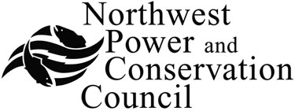 | Bruce A. Measure  Vice-Chair  Montana
James A. Yost  Idaho  Frank L. Cassidy Jr.  “Larry”  Washington  Tom Karier  Washington |  | Rhonda Whiting  Montana  Melinda S. Eden  Oregon  Joan M. Dukes  Oregon

Generating Resources Advisory Committee

FINAL AGENDA

Thursday July 17, 2008
10:00 AM - 3:00 PM

Northwest Power and Conservation Council Central Offices
851 SW Sixth Avenue
Suite 1100
Portland, Oregon 97204
1-877-848-1997 Guest Code: 319

10:00 Introductions, Announcements & Review of Agenda
Set meeting schedule

10:15 Overview of the Sixth Power Plan & Role of the Generating Resources Advisory Committee– Jeff King

11:00 Preliminary Sixth Power Plan Wholesale Price & CO₂ Forecast – Maury Galbraith
Modeling approach
Data and assumptions
Findings
Next steps

11:50 Break for lunch

1:00 Proposed planning assumptions - Aeroderivative simple-cycle combustion turbines – Jeff King

1:40 Proposed planning assumptions - Heavy-duty simple-cycle combustion turbines – Jeff King

2:00 Proposed planning assumptions - Reciprocating engine-generators – Maury Galbraith

2:20 Assessment of operating and maintenance costs - Maury Galbraith

2:40 Wrap-up - Jeff King

3:00 Adjourn

________________________________________

q:\jk\wind integration ap\twg\twg 092506\twg agenda for 092506 082306.doc

