W. Bill Booth  Chair  Idaho | 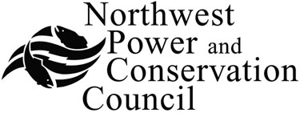 | Bruce A. Measure  Vice-Chair  Montana
James A. Yost  Idaho  Tom Karier  Washington  Dick Wallace  Washington |  | Rhonda Whiting  Montana  Melinda S. Eden  Oregon  Joan M. Dukes  Oregon

Generating Resources Advisory Committee

AGENDA

Thursday September 25, 2008
10:00 AM - 3:00 PM

Northwest Power and Conservation Council Central Offices
851 SW Sixth Avenue
Suite 1100
Portland, Oregon 97204
1-877-848-1997 Guest Code: 319

10:00 Call to order - Jeff King
Introductions
Review of agenda
Approval of minutes of August 21 meeting

10:15 Portfolio Risk model - Michael Schilmoeller

11:15 Proposed resource development parameters - Jeff King

Noon Break for lunch

1:15 Proposed combined-cycle power plant capital cost assumptions - Jeff King

2:00 Thermal resource commitment parameters - Maury Galbraith

2:40 Status of ongoing action items
Wind resource assessment
Assessment of ancillary services
Thermal plant operating and maintenance cost assessment
Pumped storage workshop

3:00 Adjourn

