Upstream Methane &

The 2021 Power Plan

Contents

Summary 1

Introduction 2

Methane Emission Studies 3

Standardization of Study Results 5

Fuel Emission Rate Calculation & Results 6

Coal 6

Natural Gas 7

Methane emission rate for the Northwest 8

Application to regional natural gas and coal power plants 9

Results 9

# Summary

A methodology was developed to incorporate the upstream methane emissions related to the production of natural gas and coal into the planning models for the 2021 Northwest Power Plan.

Traditionally, upstream methane emissions from the natural gas and oil supply system have been estimated using inventory-based models. Over past five years, new measurement techniques have been developed to study the issue, and the related studies indicate that the inventory models may be underestimating the amount of methane that is being released to the atmosphere upstream of the natural gas delivery points.

This paper outlines the results from five studies of upstream methane and presents a method to standardize the results in order to calculate an estimate of the percent of delivered methane that is released upstream. This released rate is used to develop an upstream fuel emission rate that can be added to the combustion emission rate to complete a better picture of the emissions related to natural gas (and coal). A specific emission rate for the natural gas and coal delivered to the Northwest was also developed.

**Table 2: Fuel emission rates for natural gas and coal in the Northwest**

|  |  |  |  |  |
| --- | --- | --- | --- | --- |
| **Carbon Dioxide Equivalents**  **lbs. CO2e/MMBtu** | | **Combustion** | **Upstream Methane** | **Total** |
| Natural Gas | Upstream methane release rate *Ld* = 1.37% | 118 | 18.4 | 136 |
| Coal | Surface mining methane emission rate of 38.7 scf. CH4 per ton of coal | 216 | 3.5 | 219 |

# Introduction

Natural gas has been undercutting coal as a fuel for electricity generation for some time now. With technological advances in shale oil and gas extraction - fracking and horizontal drilling – gas has become cheaper than coal and emits less CO2 when burned to generate electricity. Energy efficiency, wind, solar and natural gas all have displaced generation from coal, leading to a cleaner electrical grid in terms of CO2 emissions. Natural gas also plays a key role in the region with heating homes and businesses as an end-use fuel.

However, the primary component of natural gas is methane (CH4) which, pound for pound, has 34 times the global warming impact as CO2 over 100 years, and 86 times over 20 years. Methane that is released directly into the atmosphere is a big deal. The oil and natural gas supply chain that we rely on to deliver the gas from many hundreds of miles away to our homes, businesses, and power plants emits methane along the way.

The global atmospheric concentration level of methane has been increasing at an alarmingly rapid pace since 2007. The National Oceanic and Atmospheric Administration (NOAA) tracks methane levels in the atmosphere.[1] The most recent numbers show that methane levels jumped significantly in 2019, indicating the methane problem is getting worse. It’s not clear what all the causes are, but oil and natural gas activities contribute a significant portion of the overall global methane emissions.

The Environmental Protection Agency (EPA) reports an annual estimate of methane emissions from oil and natural gas activities in the US. The EPA use a bottoms-up inventory method which sums up the potential emissions throughout the supply chain from equipment operating as designed. However, recent studies by research institutions and coordinated by the Environmental Defense Fund (EDF)[2] have found actual methane releases from the oil and gas system in the US to be significantly higher. In addition, a recently published study in Nature suggests global-wide fossil related methane emissions are higher than the bottoms-up inventory methods indicate.

In our current power planning models, fuel emission rates for natural gas and coal plants are based on emissions at the point of electricity generation and do not account for upstream emissions. The method outlined in this report combines an emission rate derived from estimated upstream methane releases with established combustion related emission rates – to produce an overall fuel emission rate based on delivered fuel.

For emissions at the point of combustion, the EPA publishes greenhouse gas (GHG) rates for coal and natural gas power plants[3]. These rates are expressed in terms of pounds of GHG per MMBtu of fuel consumed shown in Table 2.

The emission rates for each gas are converted to CO2 equivalents (CO2e) using the values from the 5th Assessment of the IPCC Intergovernmental Panel on Climate Change[4] shown in Table 3.

**Table 2: Emission rates - fuel combustion**

|  |  |  |  |
| --- | --- | --- | --- |
| **GHG** | **Units** | **Natural Gas** | **Coal (sub-bit)** |
| CO2 | Ton/MMBtu | 0.05844 | 0.10695 |
| CH4 | Lbs./MMBtu | 0.0022 | 0.02425 |
| N2O | Lbs./MMBtu | 0.0022 | 0.00353 |

**Table 3: CO2 equivalents (CO2e)**

|  |  |
| --- | --- |
| **Greenhouse Gas** | **Global Warming Potential Factor- 100 Year** |
| CO2 | 1 |
| CH4 | 34 |
| N2O | 298 |

# Methane Emission Studies

From 2012 through 2017, EDF coordinated numerous scientific studies to measure methane releases from the oil and gas system. Scientists and industry professionals performed ground based, facility-scale methane emission measurements across 30 % of the gas production areas in the US and scaled up to an annual estimate. The ground-based results were verified with aircraft measurements. The studies found that most of the methane releases are occurring upstream in the production, gathering, and processing stages. They also found that actual methane emissions are much higher than estimates would indicate using the bottoms-up inventory method. Some of the discrepancy may be due to the facility-scale measurement methods catching equipment that had failed or was operating sub-optimally.

The National Energy Technology Laboratory (NETL) and Carnegie Mellon University (CMU) teamed up on a study to use the NETL life cycle model to synthesize an estimate of methane emissions. They also utilized some of the new data from the EDF study, along with the EPA inventory data as input. One of their key findings was that 19 % of the methane emissions were “unassigned”, indicating that there is a gap as to why site-level measurements show higher emissions than bottoms-up inventory analysis. This study also did not explicitly consider the methane leaks from the oil system like the EDF coordinated studies – though a significant amount of marketed natural gas is produced from oil drilling (associated gas).

The International Energy Agency (IEA)[5] just released methane emission estimates with their Methane Tracker 2020 tool. This tool estimates emissions from the full oil and natural gas supply chain, including methane releases from unintended leaks (fugitives), intended releases (venting) and incomplete flaring.

The EPA publishes an annual report - *Inventory of Greenhouse Gas Emissions and Sinks* - that includes separate estimates of emissions of methane from the natural gas and petroleum (oil) systems in the US. Data for this study was pulled from the most recent final report[6], along with the supplemental documents that includes uncertainty estimates, for the emission year 2017.

Supplemental environmental impact statements were completed in 2019 for two proposed natural gas related projects in the state of Washington:

* Kalama Manufacturing & Marine Export Facility[7]
* PSE Tacoma LNG Project[8]

Ecology and Environmental Inc and Life Cycle Associates published a study for these projects that estimated emissions related to these two projects, including upstream methane. The study used a life cycle analysis tool used in Canada – GHGenius – to calculate emissions from natural gas production and transportation from British Columbia[9]. A summary of the results used for this study is in Table 5. The GHGenius model is similar to the EPA method in that it is an inventory model; GREET is a similar inventory model for North America.

**Table 4: Upstream methane studies and estimates**

|  |  |  |  |  |  |  |
| --- | --- | --- | --- | --- | --- | --- |
| **Study** | **Publication** | **Emission Source** | **Emission Year** | **Est. – Tg** | **Low – Tg** | **High – Tg** |
| EDF Coord. | *Assessment of methane emissions from the U.S. oil and gas supply chain*  Science *13 Jul 2018: Vol. 361, Issue 6398, pp. 186-188 DOI: 10.1126/science.aar7204* | US Oil & Natural Gas Systems | 2015 | 13.2 | 11.5 | 15.3 |
| NETL/CMU | *Synthesis of recent ground-level methane emission measurements*  *from the U.S. natural gas supply chain*  Journal of Cleaner Production 148 (2017) 118-126 | US Natural Gas System | 2012 | 7.3 | 5.6 | 9.5 |
| IEA  *Methane Tracker 2020* | [*https://www.iea.org/reports/methane-tracker-2020*](https://www.iea.org/reports/methane-tracker-2020) | US Oil & Natural Gas Systems | 2019 | 11.38 |  |  |
| US Natural Gas System | 2019 | 7.95 |  |  |
| EPA | *Inventory of Greenhouse Gas Emissions and Sinks: 1990-2017* | US Oil & Natural Gas Systems | 2017 | 8.41 | 6.90 | 10.05 |
| US Natural Gas System | 2017 | 6.62 | 5.56 | 7.75 |

**Table 5: Upstream methane emissions-EIS for Tacoma LNG and the Kalama Export Facility**

|  |  |  |
| --- | --- | --- |
| **Upstream Methane Emissions** | **g/MMBtu (LHV)** | **g/MMBtu (HHV)** |
| GHGenius (BC inventory) | 153 | 138 |
| GREET (NA Inventory) | 221 | 200 |

There is concern that inventory-based models (EPA, GHGenius) are significantly under-estimating actual methane releases. In early 2020, Nature published a paper on global-wide fossil methane emissions.[10] Global fossil methane emission estimates are allocated into source-based categories based on inventory-based estimates for:

* anthropogenic (such as oil and gas)
* natural geologic (such as seeps, mud volcanoes)

Scientists used ice-core samples to study the natural geologic fossil methane releases from pre-industrial era years. They found much lower natural emissions than the current inventory studies report. This points to actual fossil methane emissions from anthropogenic sources – such as oil and gas - being higher than the what the bottoms-up inventory estimates produce.

# Standardization of Study Results

For each of the studies outlined in Table 4 and 5, a standardized upstream methane release rate - *Ld* - was calculated. This value represents the percent of the delivered methane that is released upstream. Each study estimates an overall amount of methane that was leaked or released to the atmosphere in a given emission year. By dividing this value by the total delivered methane in that year, a standardized value *Ld* can be computed and compared across studies. The delivered methane value was derived from the EIA reported historic quantities of delivered natural gas[11].

For the GHGenius BC model, the methane emission rate (g CH4/MMBtu natural gas) was converted to a leakage rate using a value of 17,954 g CH4 per delivered MMBtu of delivered natural gas.

**Table 6: Standardized upstream methane leakage rates**

|  |  |  |  |
| --- | --- | --- | --- |
| **Study Result** | **Emission Source** | **Emission Year** | ***Ld* %  percent of delivered methane that is released upstream** |
| EDF High | Oil & NG | 2015 | 3.29 |
| EDF | Oil & NG | 2015 | 2.84 |
| EDF Low | Oil & NG | 2015 | 2.47 |
| NETL/CMU High | NG only | 2012 | 2.18 |
| EPA High | Oil & NG | 2017 | 2.18 |
| IEA | Oil & NG | 2019 | 2.16 |
| EPA | Oil & NG | 2017 | 1.82 |
| NETL/CMU | NG only | 2012 | 1.69 |
| EPA High | NG only | 2017 | 1.67 |
| IEA | NG only | 2019 | 1.51 |
| EPA Low | Oil & NG | 2017 | 1.49 |
| EPA | NG only | 2017 | 1.42 |
| NETL/CMU Low | NG only | 2012 | 1.29 |
| EPA Low | NG only | 2017 | 1.20 |
| GHGenius | NG only (British Columbia) | 2019 | 0.77 (HHV) |

# Fuel Emission Rate Calculation & Results

The greenhouse gas emissions from future estimates of consumption of natural gas and coal are considered throughout our energy planning models. Fuel emission rates for natural gas and coal – lbs. of GHG per MMBtu of fuel consumed – are used to convert expected fuel consumption into emission estimates. Previously, our planning models have only considered emissions at the point of combustion. For the 2021 Power Plan, upstream methane emissions resulting from the delivery of fuel to point of combustion will also be included.

## Coal

The coal consumed in the Northwest is surfaced mined from the Power River Basin (PRB). Generally, surface mined coal releases methane at a lower rate than underground mines. The EPA and National Energy Technology Lab (NETL) have reported that surface mine emissions are difficult to quantify since they are not coming from a point source; but studies have suggested a value of 38.7 standard cubic feet of CH4 per ton of coal mined[12].

The standard delivered unit of coal is 1 MMBtu. An assumption of supply chain loss of 10%, along with the MMBtu to lbs. conversion value for PRB coal is used to calculate a rate of lbs. of CH4 emitted upstream per MMBtu of coal delivered of 0.103. The combined results for coal are show in Table 7.

**Table 7: Coal emission rate for the Northwest – on a per unit of fuel delivered basis**

|  |  |  |
| --- | --- | --- |
| **Mining methane emission rate of 38.7 scf. CH4 per ton of coal** | **Greenhouse Gas**  **lbs. GHG/MMBtu** | **Carbon Dioxide Equivalents**  **lbs. CO2e/MMBtu** |
| Combustion |  |  |
| CO2 | 213.9 | 213.9 |
| CH4 | 0.02425 | 0.8245 |
| N2O | 0.00353 | 1.0519 |
| Total Combustion |  | 216 |
| Upstream |  |  |
| CH4 | 0.103 | 3.51 |
| Total |  | 219 |

## Natural Gas

The standard unit of delivered fuel is 1 MMBtu of natural gas. Assuming a methane composition of around 97% for delivered gas, and a conversion factor, this equates to a value of 39.6 lbs. of CH4 delivered per MMBtu of natural gas delivered. Multiplying this value by the upstream methane release rate *Ld* produces an upstream methane emission rate on a lbs. of CH4 per MMBtu of delivered natural gas basis. Figure 1 shows the relationship between the upstream methane release rate *Ld* and the upstream emission rate in carbon dioxide equivalents for gas.

**Figure 1: Upstream methane emission rate as a function of the upstream release rate**

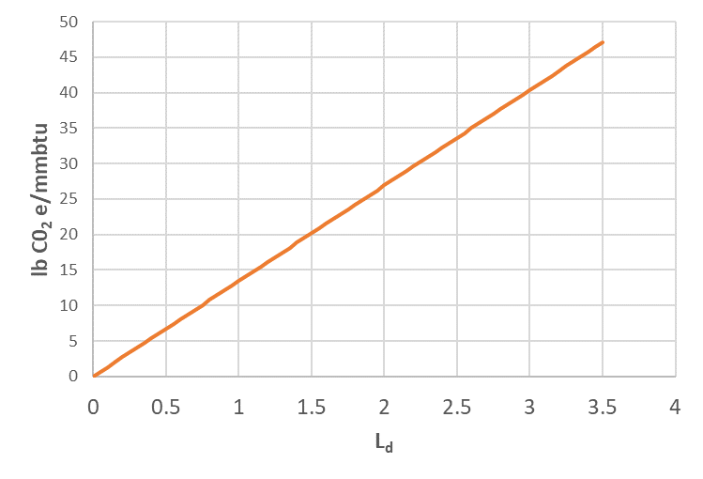

### Methane emission rate for the Northwest

A value of 1.37 % was estimated for the upstream methane release rate *Ld* for natural gas delivered to the Northwest. This value is based on a few key assumptions – the current and future natural gas source mix, and the associated methane release rates.

Currently, roughly 65 % of the gas delivered for use in the Northwest is from Western Canada (British Columbia and Alberta), and 35 % from the US Rockies (Utah, Wyoming, Colorado). This is approximate, and the mix may change over time, which adds a layer of uncertainty. For regional upstream methane release rates *Ld*, the GHGenius model value of 0.77 % was used, and for the US Rockies 2.47%, the low estimate from the EDF studies for the US. Over time, with either new regulation, or volunteer efforts by the industry, the methane release rate from the US Rockies was assumed to improve over time and eventually decline to 0.77 %.

Table 8 shows the key factors for setting the Northwest upstream methane release rate, and Table 9 displays the resulting natural gas emission factors.

**Table 8: Northwest upstream methane release rate**

|  |  |  |  |
| --- | --- | --- | --- |
| **Region** | ***Ld* %** | **% of regional gas** | **Source** |
| Northwest Planning Region | 1.37 |  | Weighted average of loss estimates for BC/Canadian gas and US Rockies gas |
| BC/AB | 0.77 | 65 | Calculated from the inventory model GHGenius with BC sourced gas |
| US Rockies | 2.47 | 35 | Low range of EDF coordinated studies measuring facility-scale emissions from US gas regions including the Rockies |

**Table 9: Northwest natural gas emission rate – on a per unit of fuel delivered basis**

|  |  |  |
| --- | --- | --- |
| **Upstream methane release rate *Ld* = 1.37%** | **Greenhouse Gas**  **lbs. GHG/MMBtu** | **Carbon Dioxide Equivalents**  **lbs. CO2e/MMBtu** |
| Combustion |  |  |
| CO2 | 116.88 | 116.88 |
| CH4 | 0.0022 | 0.0748 |
| N2O | 0.0022 | 0.6556 |
| Total Combustion |  | 118 |
| Upstream |  |  |
| CH4 | 0.541 | 18.38 |
| Total |  | 136 |

## Application to regional natural gas and coal power plants

The full emission rates from Tables 7 and 9 were applied to historic power plant generation for the year 2016. Data for individual power plants – including generation (MWh) and plant heat rates (Btu/kWh) for the year 2016 was pulled from the EPA Emissions & Generation Resource Integrated Database (eGRID) and analyzed. Table 10 shows the resulting full emission rate on a Lbs. of CO2e per MWh basis for weighted regional power plant averages.

**Table 10: Generation emission rates for regional power plants**

|  |  |  |
| --- | --- | --- |
| **Year 2016** | **Regional Natural Gas Power Plants** | **Regional Coal Power Plants** |
| *Ld* % | 1.37 |  |
| Generation weighted average heat rate |  |  |
| Btu/kWh | 7,716 | 11,047 |
| Emission rate – combustion + upstream methane |  |  |
| Lbs. CO2e/MWh | 1,049 | 2,423 |

## Results

Figure 2 shows the estimated leakage rates by study. The following two figures show the resulting fuel emission rates.

**Figure 2: Upstream methane release rate - % of delivered methane that is released upstream *Ld***

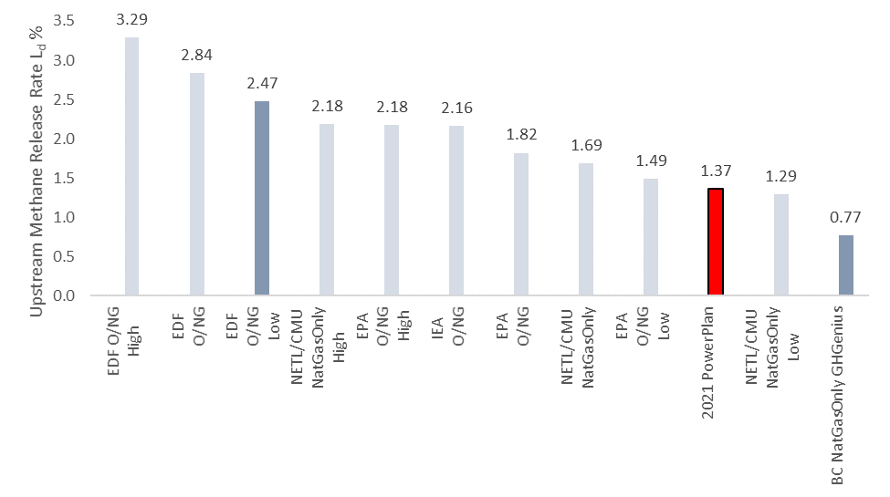

**Figure 3: Fuel emission rate per unit of fuel delivered in carbon dioxide Equivalents for coal and natural gas**

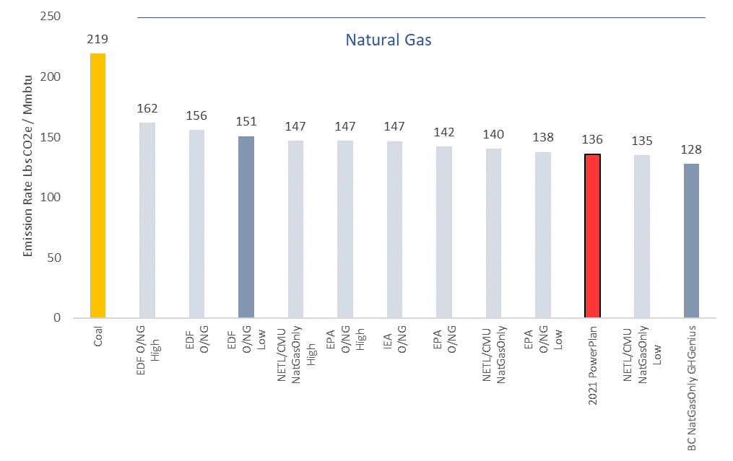

1. <https://www.esrl.noaa.gov/gmd/ccgg/trends_ch4/>
2. <https://www.edf.org/sites/default/files/EDF-Methane-Science-Brochure.pdf>
3. <https://www.epa.gov/sites/production/files/2018-02/documents/egrid2016_technicalsupportdocument_0.pdf>
4. <https://www.c2es.org/content/ipcc-fifth-assessment-report/>
5. <https://www.iea.org/articles/global-methane-emissions-from-oil-and-gas>
6. https://www.epa.gov/ghgemissions/inventory-us-greenhouse-gas-emissions-and-sinks-1990-2017
7. <https://kalamamfgfacilitysepa.com/>
8. <https://pscleanair.gov/460/Current-Permitting-Projects>
9. <https://www.ghgenius.ca/>
10. Preindustrial 14CH4 indicates greater

    anthropogenic fossil CH4 emissions

    Benjamin Hmiel, et al.
11. http://www.eia.gov/dnav/ng/ng_cons_sum_dcu_nus_a.htm
12. National Energy Technology Laboratory, Life Cycle of Coal Exports from the Power River Basin, DOE/NETL-2016/180