W. Bill Booth  Chair  Idaho | 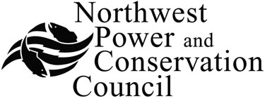 | Bruce A. Measure  Vice-Chair  Montana
James A. Yost  Idaho  Tom Karier  Washington  Dick Wallace  Washington |  | Rhonda Whiting  Montana  Melinda S. Eden  Oregon  Joan M. Dukes  Oregon
Wildlife Crediting Forum
Council Central Offices – Large Conference Rooms
851 S.W. Sixth Avenue, Suite 1100, Portland, Oregon 97204
503-222-5161
January 19, 2010 – 9:00 a.m. to 3:00 p.m.
Call-in: 800-786-1922, Guest Code: 17928867
GoToMeeting: To access GoToMeeting use the following link: https://www1.gotomeeting.com/join/156105417. Meeting ID: 156-105-417

 | 9:00 a.m. | Welcome Statements: Forum Management Officer & Chair
2. | 9:15 a.m. | Introductions and Statements by Forum Members
3. | 10:00 a.m. | Presentation (by NPCC): Current Issues & Challenges
4. | 11:00 a.m. | Identification of Key Objectives, Issues and Priorities
5. | 11:45 a.m. | Lunch Break
6. | 12:30 p.m. | Continuation: Key Objectives, Issues and Priorities
7. | 2:30 p.m. | Review of Project Schedule
8. | 2:45 p.m. | March Meeting Agenda and Target Outcome(s)

