VI. Blue Mountain Ecological Province Report

Description
The Blue Mountain Ecological Province encompasses the Snake River from the head of Lower Granite reservoir to Hells Canyon Dam including the Hells Canyon portion of the Snake River. The province also includes the tributary watersheds draining to the Snake River from the Blue Mountains in Northeast Oregon. The province includes the following subbasins:

- Asotin
- Grande Ronde
- Imnaha
- Snake Hells Canyon
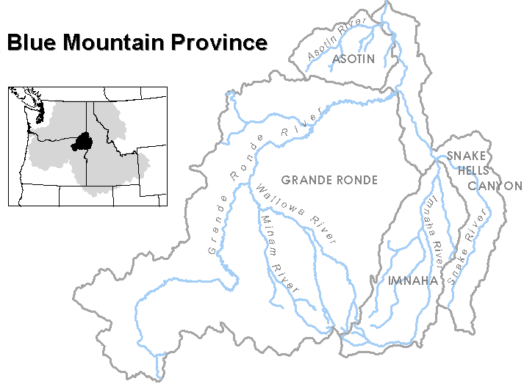
Figure VI-1. Blue Mountain Ecological Province

Results

Figure VI-2. Distribution of fish stocks within the Blue Mountain Province.
Figure VI-3. Distribution of planned releases of anadromous salmonids from hatchery programs in the Blue Mountain Province.
Figure VI-4. Distribution of planned releases of anadromous salmonids from segregated hatchery programs in the Blue Mountain Province.
Figure VI-5. Distribution of planned releases of anadromous salmonids from integrated hatchery programs in the Blue Mountain Province.
Figure VI-6. Stated purpose of anadromous salmonid hatchery programs in the Blue Mountain Province.
Figure VI-7. Funding sources for anadromous salmonid hatchery programs in the Blue Mountain Province.

Subbasin Reports

1. Asotin Subbasin
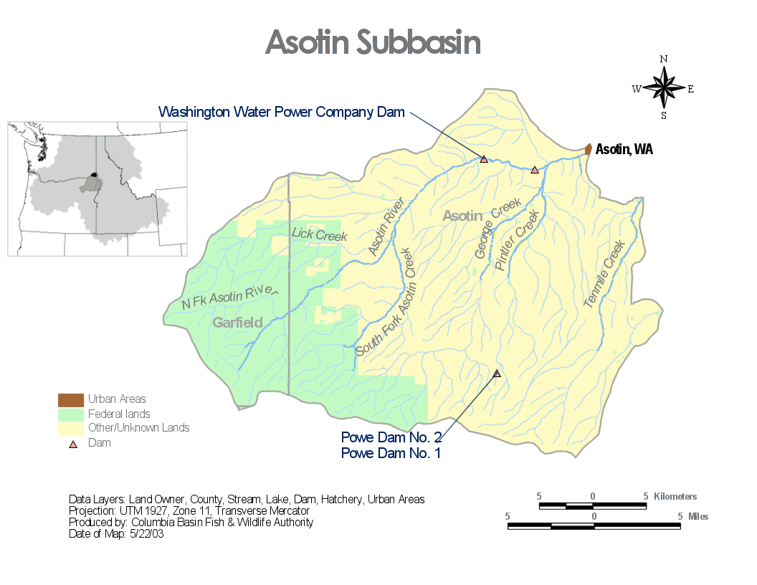
There are no Hatchery Program Reports for the Asotin Subbasin.

2. Grande Ronde Subbasin

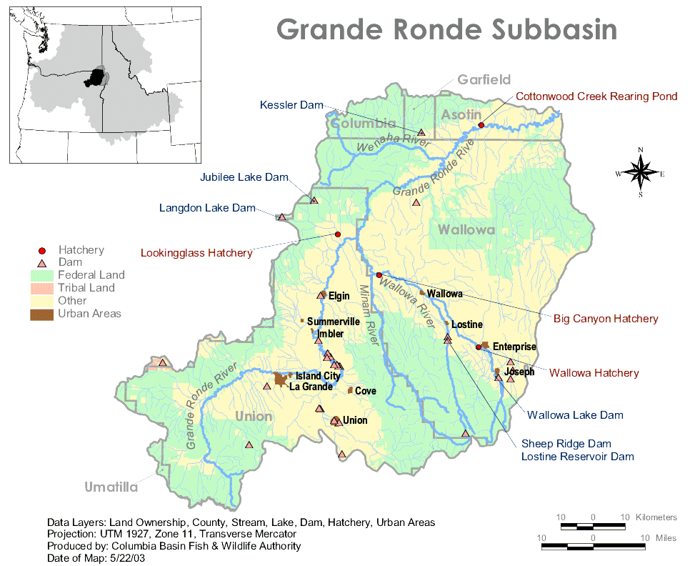
Hatchery Program Reports:

Catherine Creek Integrated Spring Chinook
Lostine Integrated Spring Chinook
Upper Grande Ronde Integrated Spring Chinook
Catherine Creek Captive Brood Spring Chinook
Grande Ronde Captive Brood Spring Chinook
Lostine Captive Brood Spring Chinook
Cottonwood Creek Hatchery Summer Steelhead
Summer Steelhead (Steelhead cross Rainbow Trout Research)
Wallowa Summer Steelhead
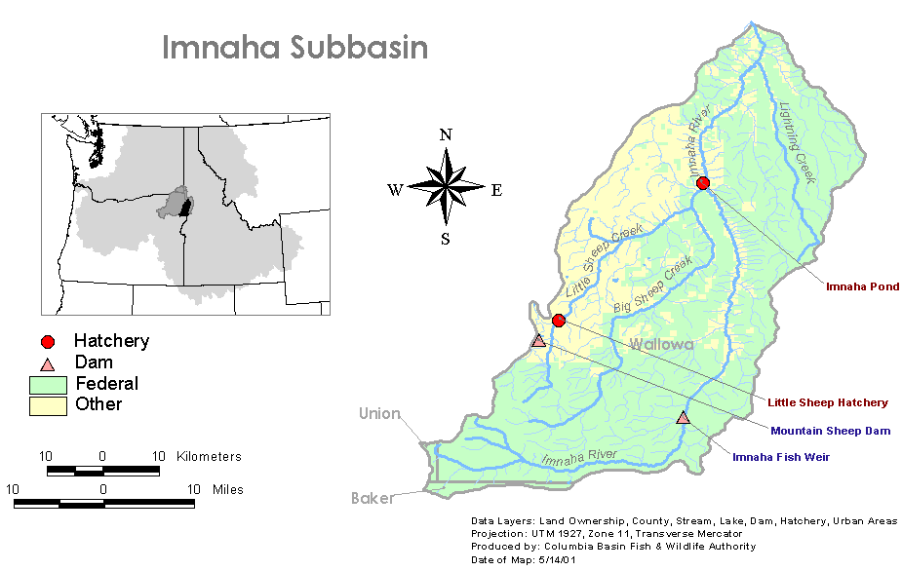
3. Imnaha Subbasin

Hatchery Program Reports:

Spring Summer Chinook – Integrated
Summer Steelhead – Integrated
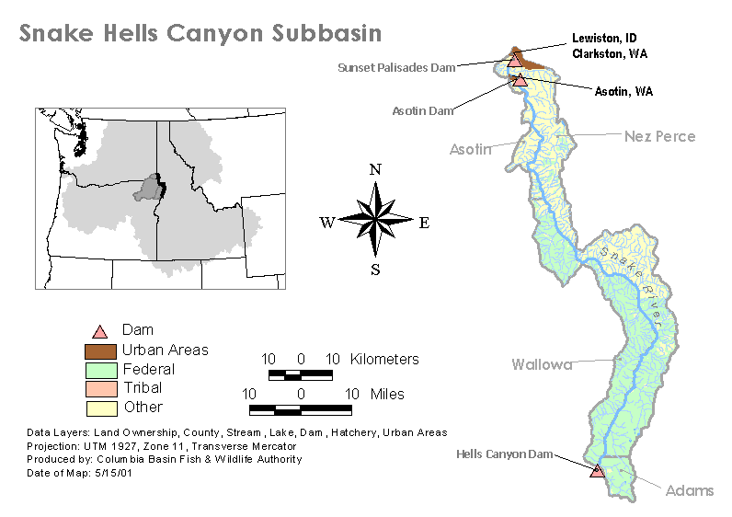
4. Snake Hells Canyon Subbasin

Hatchery Program Reports:

Captain John Integrated Fall Chinook
IPC Integrated Fall Chinook
Oxbow Fall Chinook
Pittsburg Landing Integrated Fall Chinook
Hatchery Spring Chinook
Hatchery Summer Steelhead

