V. Columbia Cascade Ecological Province Report

Description
The Columbia Cascade Ecological Province consists of the Columbia River from Wanapum Dam to the limit of anadromous fish passage at Chief Joseph Dam. Tributary subbasins are, for the most part, high gradient streams that begin in the North Cascade Mountains and drain directly to the Columbia River. The province also includes a few smaller streams that drain smaller watershed adjacent to the Columbia as well as a number of gulches that arise from the channeled scablands to the east. The province includes the following subbasins:
- Entiat
- Methow
- Okanogan
- Upper Middle Columbia
- Wenatchee

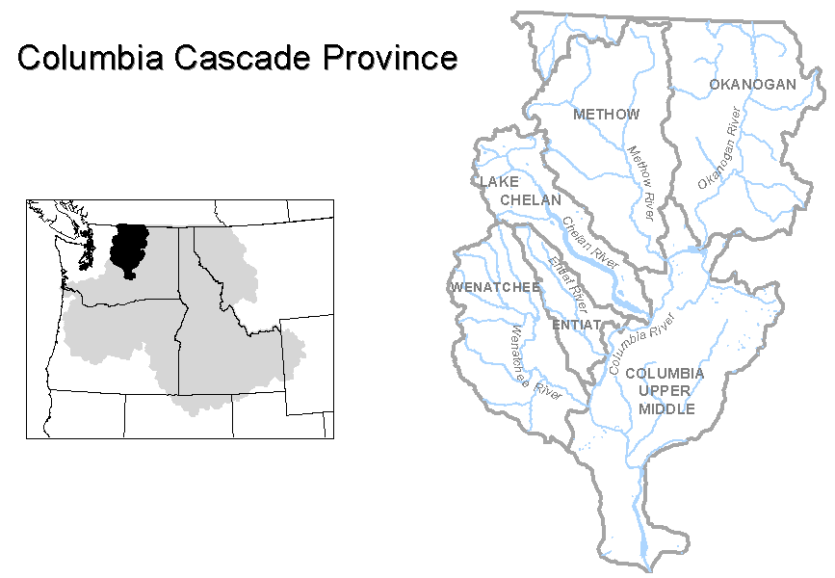
Figure V-1. Columbia Cascade Ecological Province
Results
Figure V-2. Distribution of fish stocks within the Columbia Cascade Province.
Figure V-3. Distribution of planned releases of anadromous salmonids from hatchery programs in the Columbia Cascade Province.
Figure V-4. Distribution of planned releases of anadromous salmonids from segregated hatchery programs in the Columbia Cascade Province.
Figure V-5. Distribution of planned releases of anadromous salmonids from integrated hatchery programs in the Columbia Cascade Province.
Figure V-6. Stated purpose of anadromous salmonid hatchery programs in the Columbia Cascade Province.
Figure V-7. Funding sources for anadromous salmonid hatchery programs in the Columbia Cascade Province.
Subbasin Reports
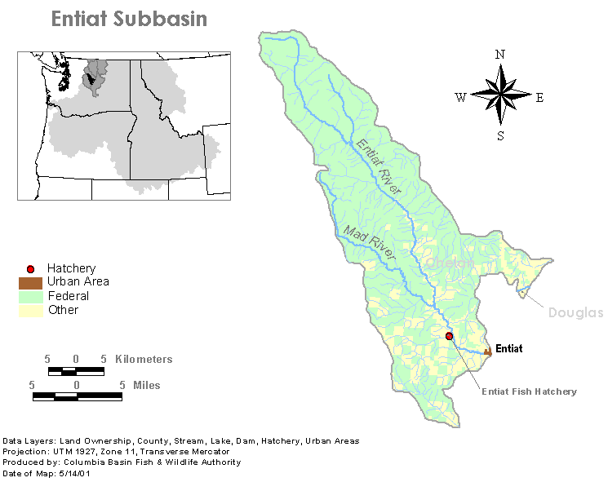
1. Entiat Subbasin

Hatchery Subbasin Reports:

Spring Chinook – Hatchery

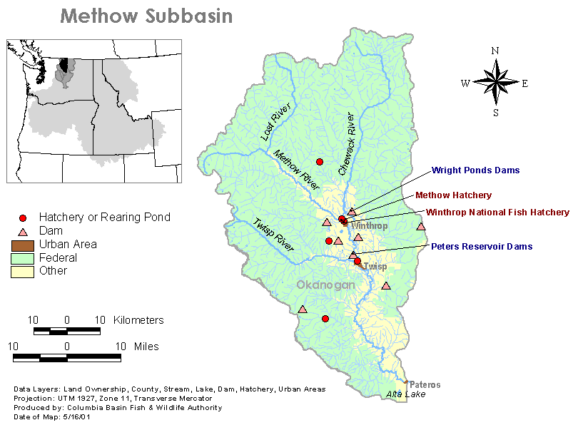
2. Methow Subbasin

Hatchery Program Reports:

Coho – Integrated
Methow Hatchery Integrated Spring Chinook
NFH Integrated Spring Chinook
Summer Chinook – Integrated
Wells Integrated Summer Steelhead
Winthrop Integrated Summer Steelhead
3. Okanogan Subbasin

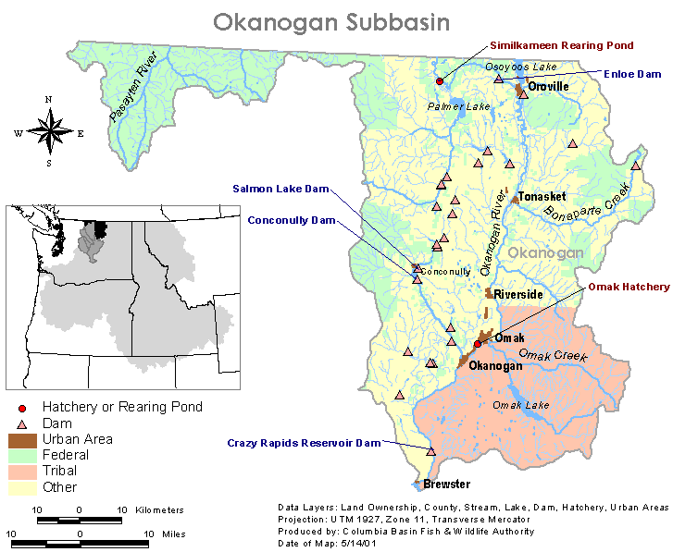

Hatchery Program Reports:

Summer Chinook Integrated
Lake Similkameen Summer Steelhead
Okanogan Summer Steelhead
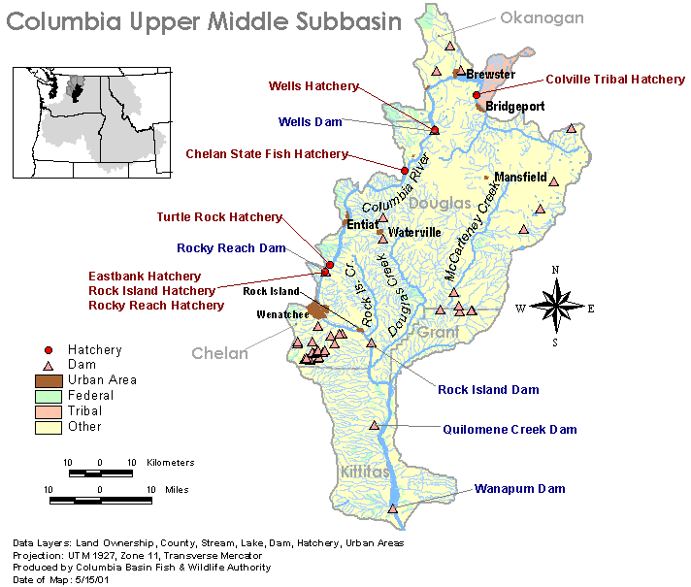
4. Columbia Upper Middle Subbasin

Hatchery Program Reports:

Ringold Fall Chinook
Wells Hatchery Summer Chinook
Summer Chinook – Integrated
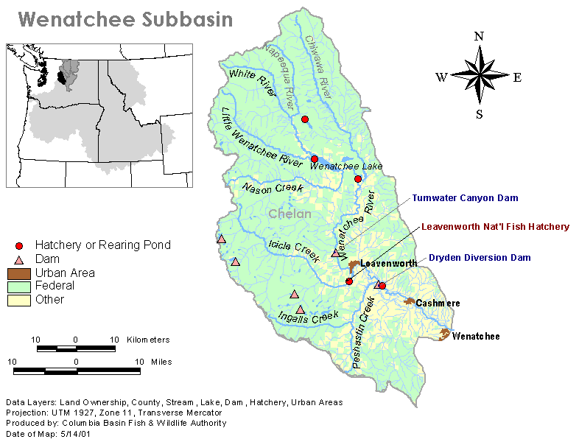
5. Wenatchee Subbasin

Hatchery Program Reports:

Coho – Integrated
Sockeye
Chiwawa River Spring Chinook
White River Captive Brood Spring Chinook
Spring Chinook – Hatchery
Summer Chinook
Summer Steelhead

