I. Columbia Estuary Ecological Province Report

Description
The Columbia Estuary Ecological Province consists of the Columbia River and associated watersheds from the mouth of the Columbia River up to, but not including, the mouth of the Cowlitz River. This province encompasses the portion of the Columbia River most directly influenced by tidal exchange and is the transitional zone between the river and the ocean. The province includes the following subbasins:
- Columbia Estuary
- Elochoman
- Grays

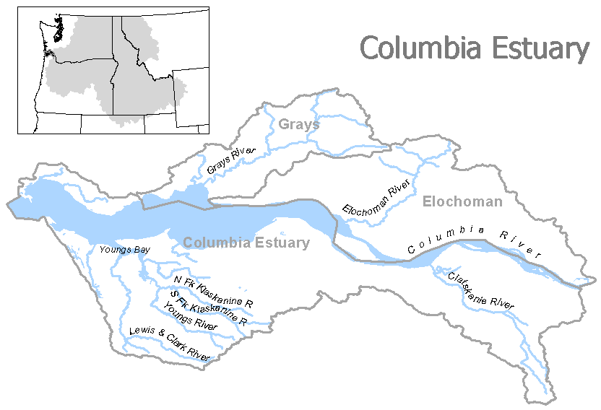
Figure I-1. Columbia Estuary Ecological Province

Results
Figure I-2. Distribution of fish stocks within Columbia Estuary Province
Figure I-3. Distribution of planned releases of anadromous salmonids from hatchery programs in the Columbia Estuary Province.

Figure I-4. Distribution of planned releases of anadromous salmonids from segregated hatchery programs in the Columbia Estuary Province.

Figure I-5. Distribution of planned releases of anadromous salmonids from integrated hatchery programs in the Columbia Estuary Province.

Subbasin Reports

1. Columbia Estuary Subbasin

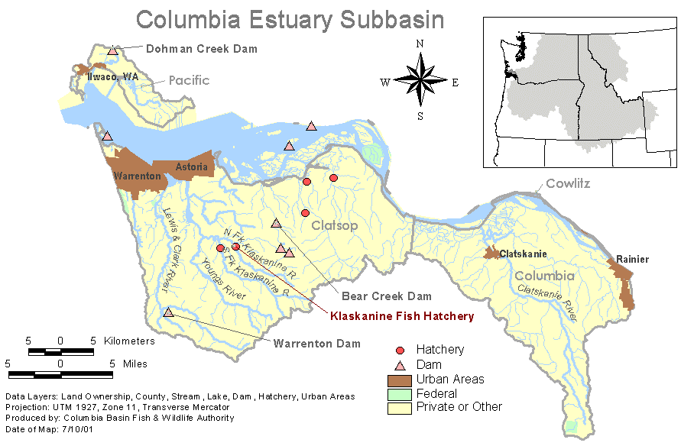
Hatchery Program Reports:

Sea Resources Integrated Chum
Big Creek Hatchery Coho
CEDC Sandy River Hatchery Coho
SAFE Tanner Creek Hatchery Coho
Steamboat Slough Hatchery Coho
Sea Resources Integrated Early Coho
Rogue CEDC Hatchery Fall Chinook
Sea Resources Integrated Fall Chinook
Big Creek Integrated Fall Chinook Tule
Grays Deep River Coho
Grays Deep River Spring Chinook
FFA Late Coho
CEDC SAFE Willamette Hatchery Spring Chinook
CEDC South Santiam Hatchery Spring Chinook
Big Creek Hatchery Winter Steelhead
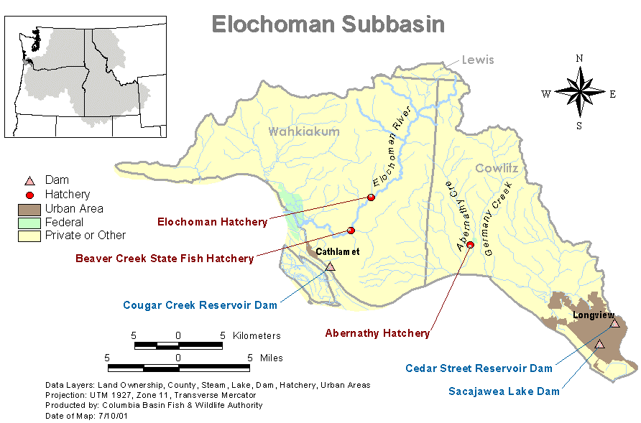
2. Elochoman Subbasin

Hatchery Program Reports:

Early Coho
Early Winter Steelhead Hatchery
Fall Chinook
Late Coho
Late Winter Steelhead-Integrated
Summer Steelhead-Hatchery
3. Grays Subbasin
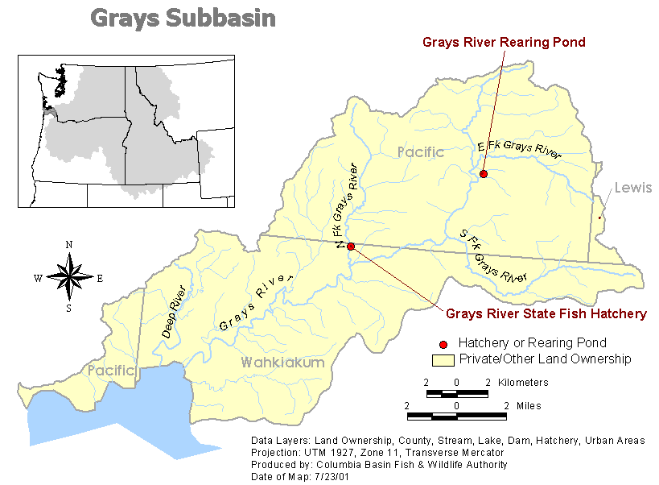
Hatchery Program Reports:

Chum
Early Coho
Early Winter Steelhead-Hatchery

