III. Columbia Gorge Ecological Province Report

Description
The Columbia Gorge Province encompasses the Columbia River and associated watersheds between Bonneville and The Dalles dams. The Gorge is a transitional environment between the relatively moist western region and the drier interior portion of the Columbia Basin. The province includes the following subbasins (Figure III-1):
  - Wind River
  - Little White Salmon
  - Big White Salmon
  - Klickitat
  - Hood River
  - Fifteenmile Creek
  - Columbia Gorge (Columbia River between Bonneville and The Dalles dams)

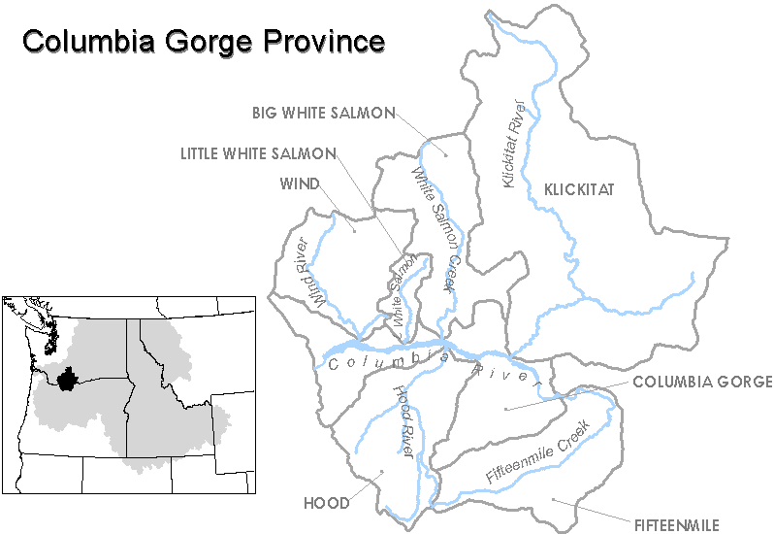
Figure III-1. Columbia River Ecological Gorge Province.

Results
Figure III-2. Distribution of fish stocks within the Columbia Gorge Province. Managers have described only anadromous salmonids stocks for this province.
Figure III-3. Distribution of planned releases of anadromous salmonids from hatchery programs in the Columbia Gorge Province.
Figure III-4. Distribution of planned releases of anadromous salmonids from segregated hatchery programs in the Columbia Gorge Province.
Figure III-5. Distribution of planned releases of anadromous salmonids from integrated hatchery programs in the Columbia Gorge Province.
Figure III-6. Stated purpose of anadromous salmonid hatchery programs in the Columbia Gorge Province.
Figure III-7. Funding sources for anadromous salmonid hatchery programs in the Columbia Gorge Province.

Subbasin Reports

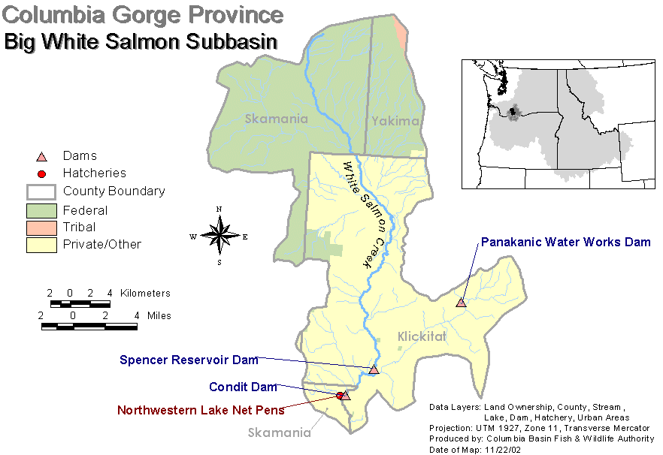
1. Big White Salmon Subbasin

Hatchery Program Reports:

Skamania Hatchery Winter Steelhead (Big White Salmon River)

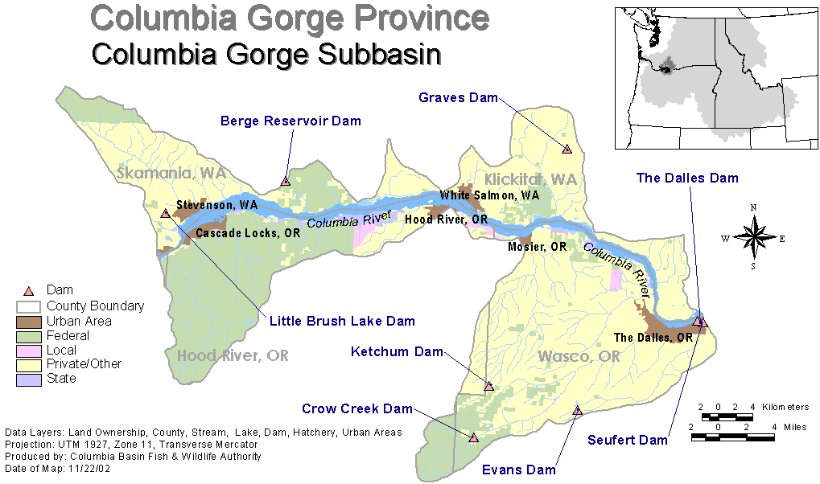
Columbia Gorge Subbasin

Hatchery Program Reports:

Tule Hatchery Fall Chinook

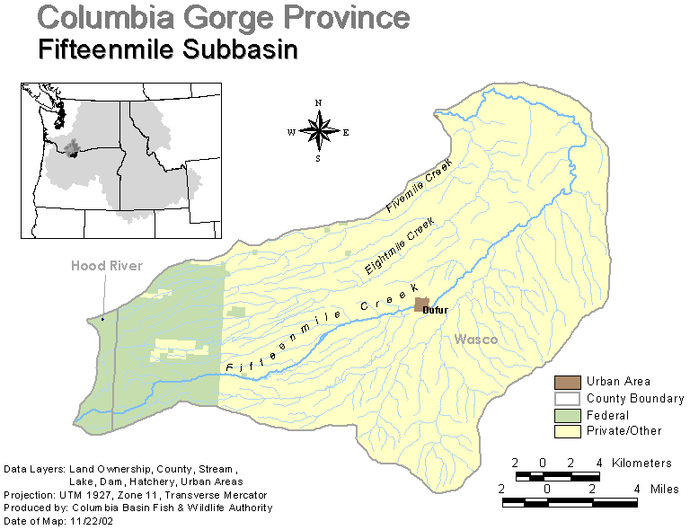
3. Fifteenmile Creek Subbasin

There are no hatchery programs in Fifteenmile Creek.

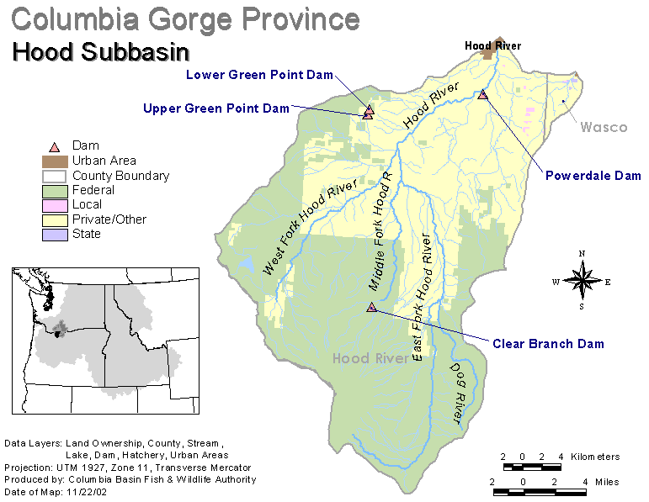
4. Hood River Subbasin

Hatchery Program Reports:

Pilot Integrated Spring Chinook
Round Butte Integrated Spring Chinook
Native Integrated Summer Steelhead
Skamania Hatchery Summer Steelhead
Winter Steelhead

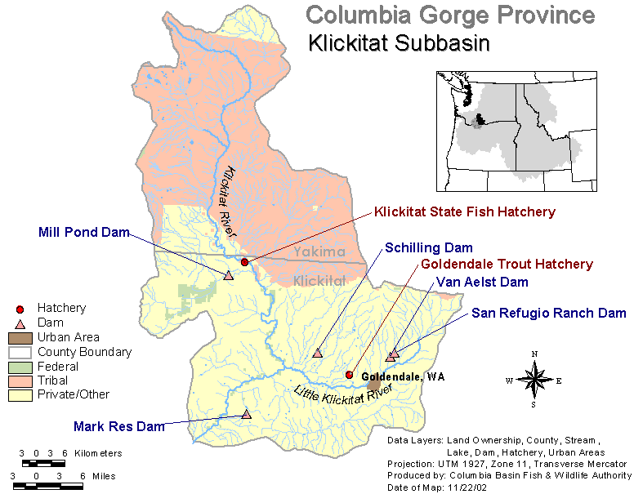
5. Kickitat River Subbasin

Hatchery Program Reports:

Klickitat Hatchery Coho
Washougal Hatchery Coho
URB Hatchery Fall Chinook
Skamania Hatchery Summer Steelhead
Spring Chinook
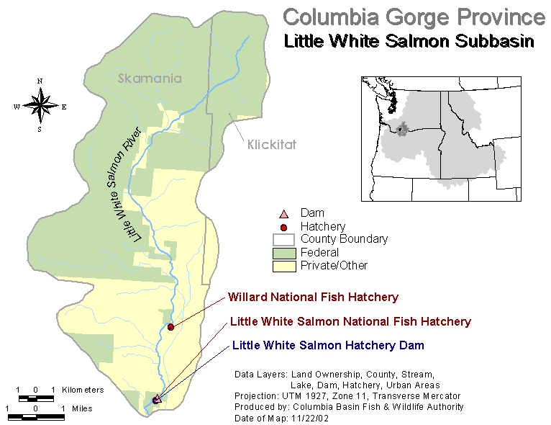
6. Little White Salmon Subbasin

Hatchery Program Reports:

Coho Hatchery
URB Hatchery Fall Chinook
Hatchery Spring Chinook
Skamania Hatchery Summer Steelhead

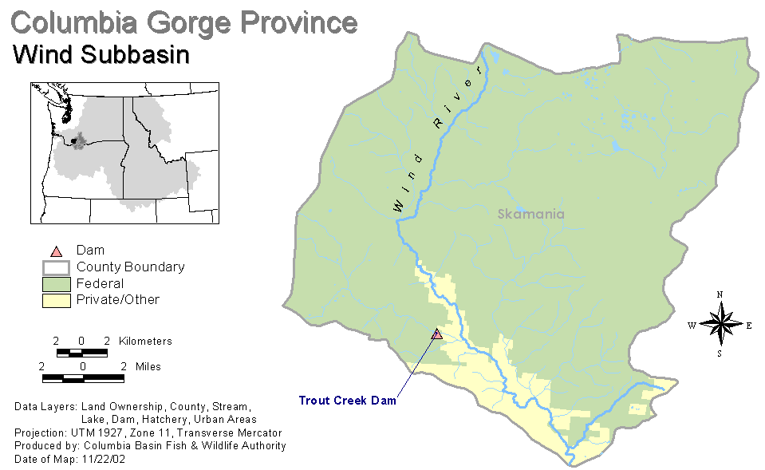
7. Wind River Subbasin

Hatchery Program Reports:

Spring Chinook Hatchery

