IV. Columbia Plateau Ecological Province Report

Description
The Columbia Plateau Province is the largest of the Ecological Provinces and is defined as the Columbia River and associated watersheds between The Dalles and Wanapum dams on the Columbia River and Ice Harbor Dam on the Snake River. The environment of the Plateau is dry and, prior to agriculture, was dominated by shrub-steppe vegetation. The hydrography of the Plateau is relatively complex and includes a number of small tributaries that drain to the mainstem rivers. However, the major subbasins that were included in this analysis include:
- Crab Creek
- Deschutes River
- Lower Middle Columbia (Columbia River from The Dalles to Priest Rapids).
- Snake Lower (Snake River from its mouth to Ice Harbor Dam
- Tucannon River
- Umatilla River
- Walla Walla River
- Yakima River
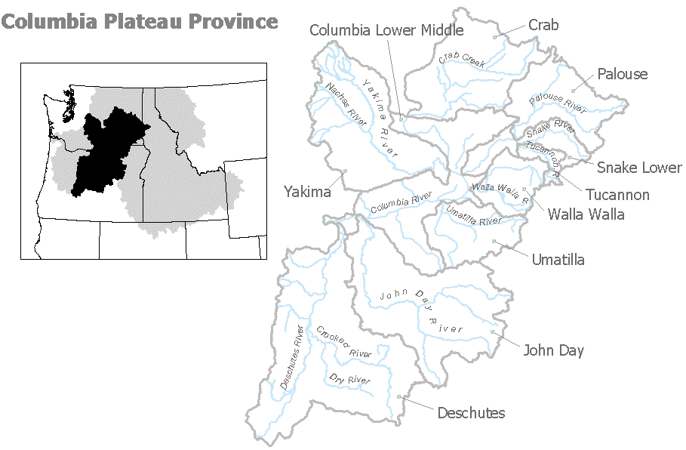
Figure IV-1. Columbia Plateau Ecological Province

Results
Figure IV-2. Distribution of fish stocks within the Columbia Plateau Province.

Figure IV-3. Distribution of planned releases of anadromous salmonids from hatchery programs in the Columbia Plateau Province.

Figure IV-4. Distribution of planned releases of anadromous salmonids from segregated hatchery programs in the Columbia Plateau Province.

Figure IV-5. Distribution of planned releases of anadromous salmonids from integrated hatchery programs in the Columbia Plateau Province.

Figure IV-6. Stated purpose of anadromous salmonid hatchery programs in the Columbia Plateau Province.

Figure IV-7. Funding sources for anadromous salmonid hatchery programs in the Columbia Plateau Province.

Subbasin Reports

1. Crab Creek Subbasin
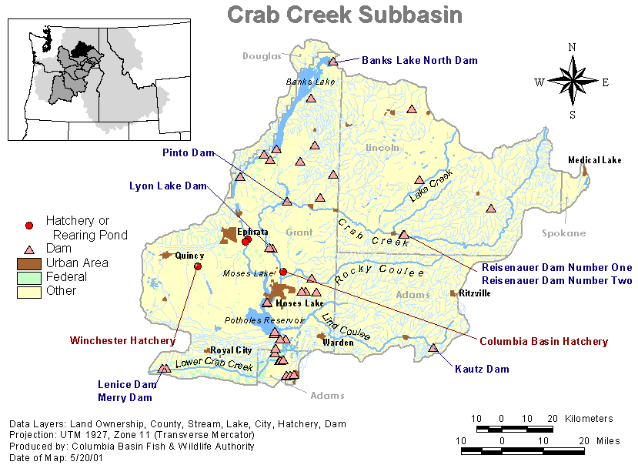

There are no Hatchery Program Reports for Crab Creek Subbasin.

2. Deschutes River Subbasin

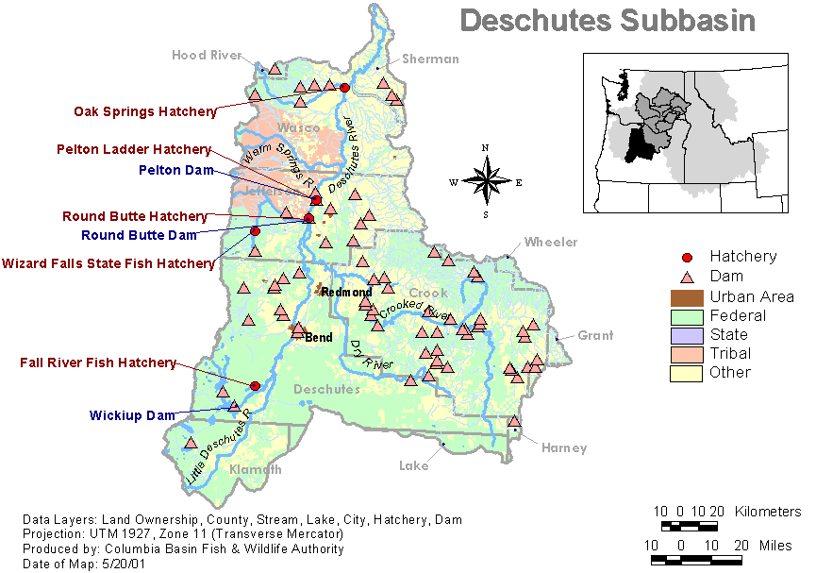
Hatchery Program Reports:

Round Butte Hatchery Spring Chinook
Steelhead – Integrated
Warm Springs Integrated Spring Chinook

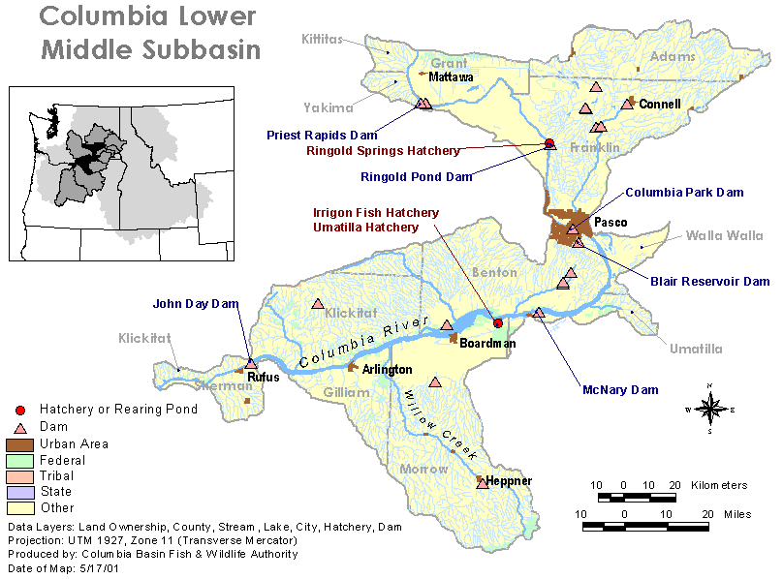
Lower Middle Columbia Subbasin

Hatchery Program Reports:

Priest Rapid URB Fall Chinook
Summer Steelhead (Ringold)

Snake Lower Subbasin

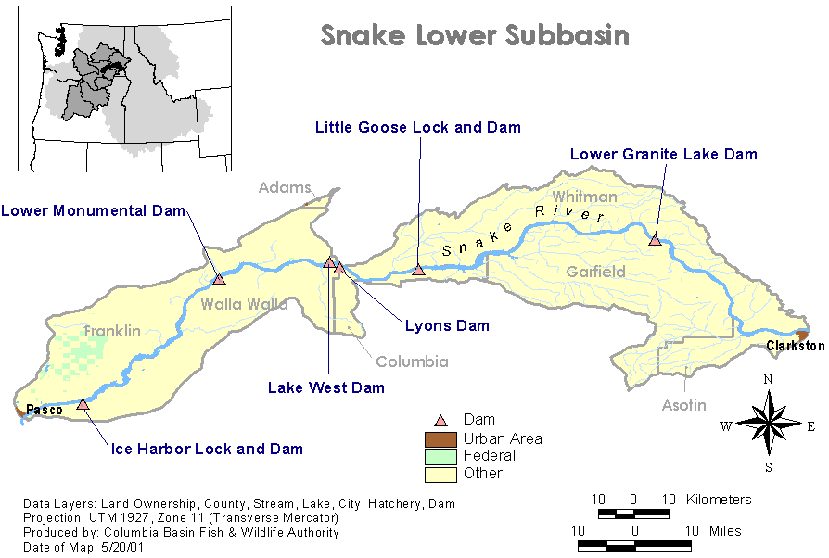
Hatchery Program Reports:

Fall Chinook – Integrated
Summer Steelhead (LF) Hatchery

Tucannon River Subbasin

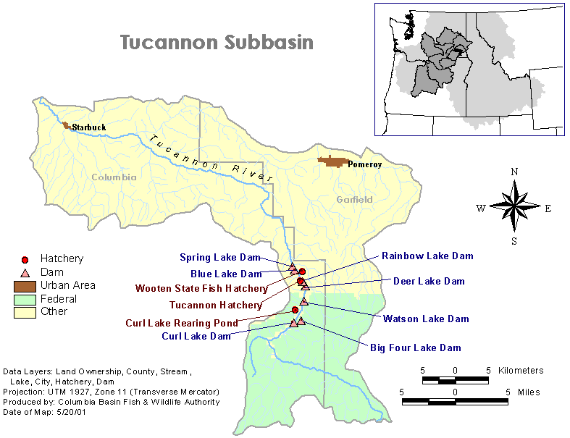

Hatchery Program Reports:

Spring Chinook – Captive Brood
Spring Chinook Integrated
Summer Steelhead (LF) Hatchery
Summer Steelhead Integrated

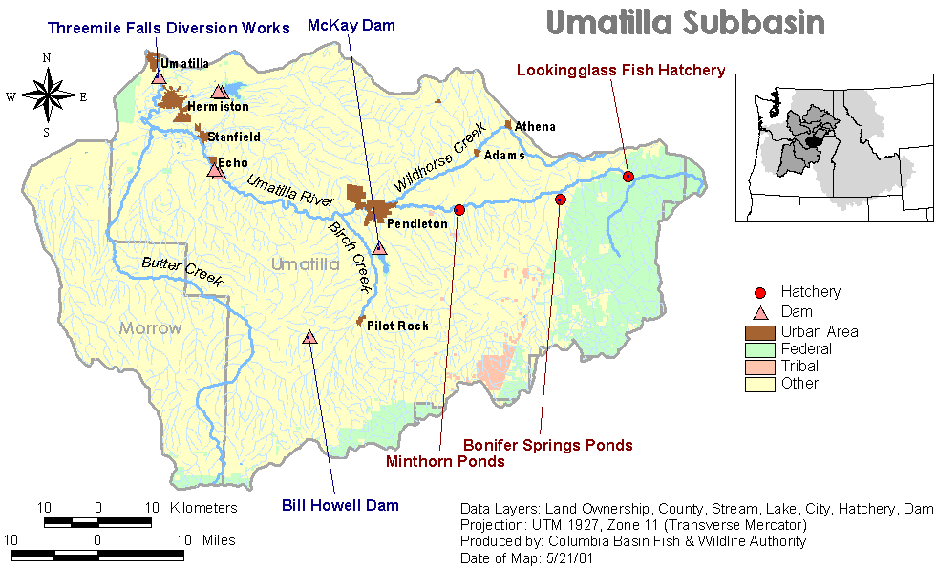
Umatilla River Subbasin

Hatchery Program Reports:

Coho – Integrated
Fall Chinook – Integrated
Spring Chinook – Integrated
Summer Steelhead – Integrated

7. Walla Walla River Subbasin

Hatchery Program Reports

Summer Steelhead (LF) Hatchery
Touchet Endemic Summer Steelhead
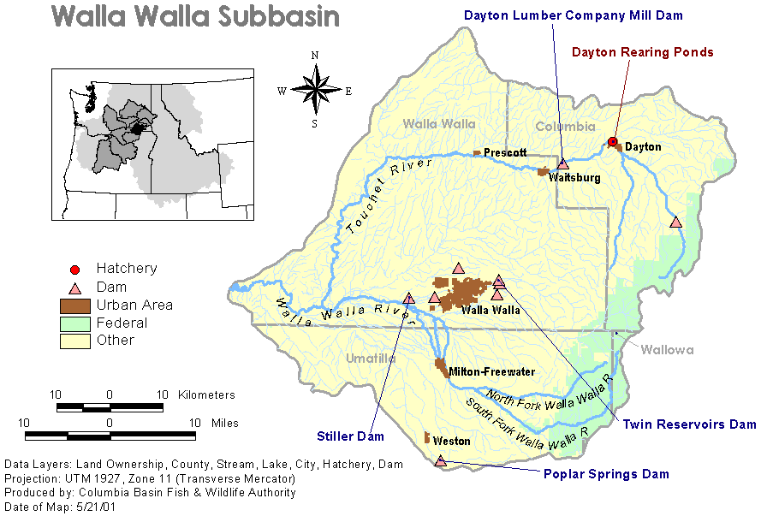

8. Yakima River Subbasin

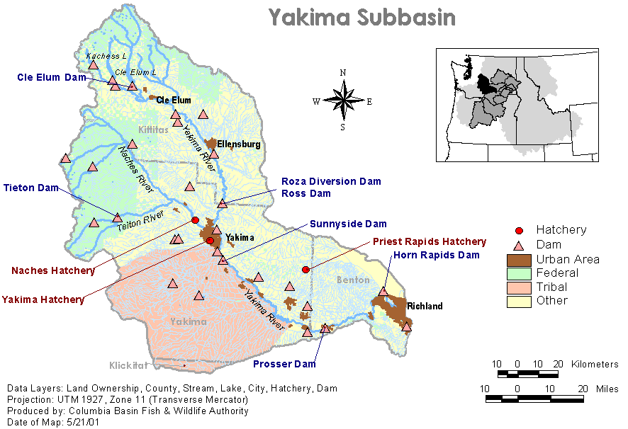
Hatchery Program Reports

Marion Drain Fall Chinook
Naches Coho
Upper Yakima Coho
Upper Yakima Spring Chinook
Yakima Fall Chinook

