II. Lower Columbia Ecological Province Report

Description
The Lower Columbia River Province occupies the lowland between the Cascade Mountains and the Coast Range. It is defined as the Columbia River and associated watersheds from Bonneville Dam to, and including, the Cowlitz River. The Lower Columbia Province is dominated by the Willamette Valley that is drained by the Willamette River, the second largest tributary in the Columbia River as well as the metropolitan area of Portland, Oregon the basin’s largest urban center. The province includes the following subbasins (Figure II-1):
- Cowlitz River
- Kalama River
- Lewis River
- Lower Columbia (Bonneville Dam to Cowlitz River)
- Sandy River
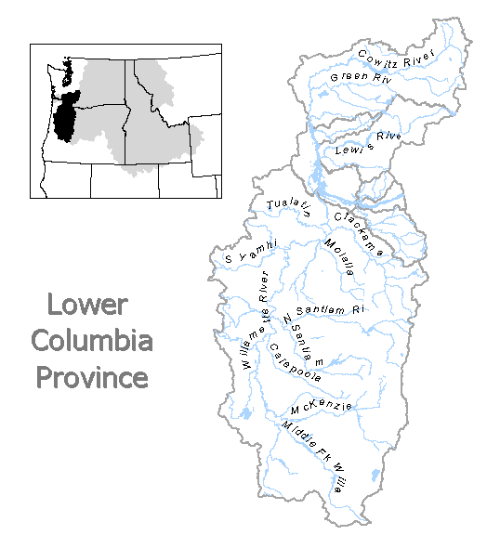
- Washougal River
Figure II-1. Lower Columbia Ecological Province
- Willamette River

Results

Figure II-2. Distribution of fish stocks within the Lower Columbia Province.
Figure II-3. Distribution of planned releases of anadromous salmonids from hatchery programs in the Lower Columbia Province.

Figure II-4. Distribution of planned releases of anadromous salmonids from segregated hatchery programs in the Lower Columbia Province.

Figure II-5. Distribution of planned releases of anadromous salmonids from integrated hatchery programs in the Lower Columbia Province.

Figure II-7. Funding sources for anadromous salmonid hatchery programs in the Lower Columbia Province.

Figure II-6. Stated purpose of anadromous salmonid hatchery programs in the Lower Columbia Province.

Subbasin Reports
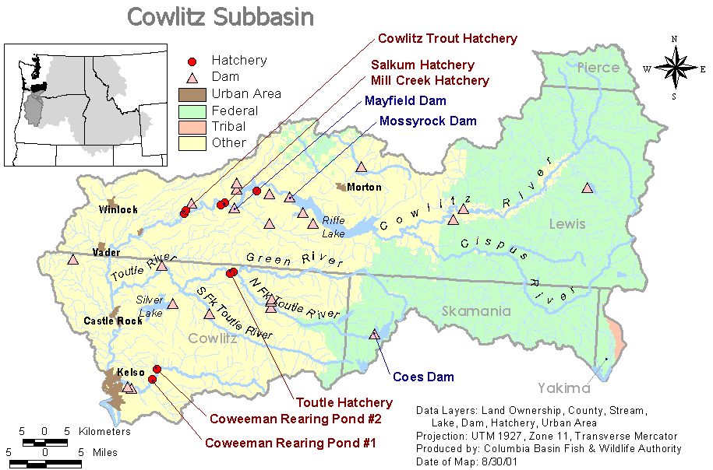

1. Cowlitz River Subbasin

Hatchery Program Reports:

Cowlitz Late Coho
Cowlitz Fall Chinook
Chambers Hatchery Early Winter Steelhead
Coweeman Early Winter Steelhead
Late Winter Steelhead
Sea-Run Cutthroat-Integrated
Skamania Hatchery Summer Steelhead (South Fork Toutle)
Toutle Early Coho
Toutle Fall Chinook

2. Kalama River Subbasin
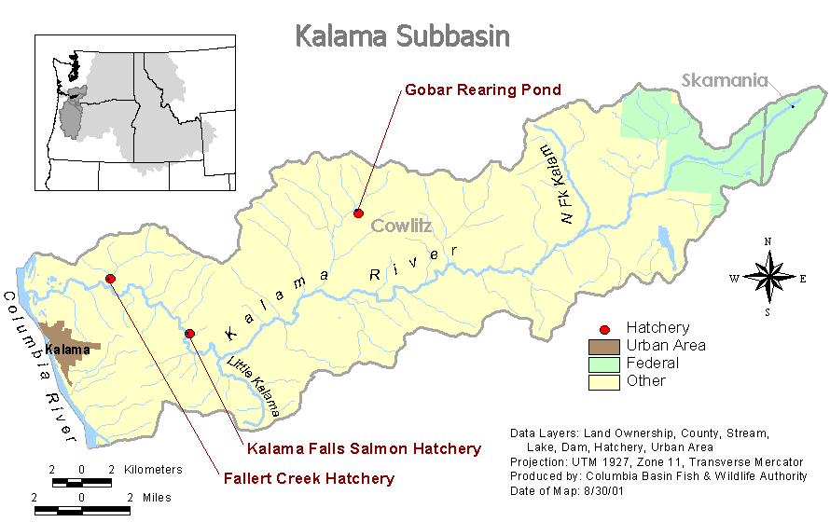
Hatchery Program Reports:

Early Coho-Hatchery
Late Coho Hatchery
Fall Chinook
Spring Chinook
Local Summer Steelhead
Skamania Hatchery Summer Steelhead
Chambers Hatchery Winter Steelhead
Local Winter Steelhead

3. Lewis River Subbasin
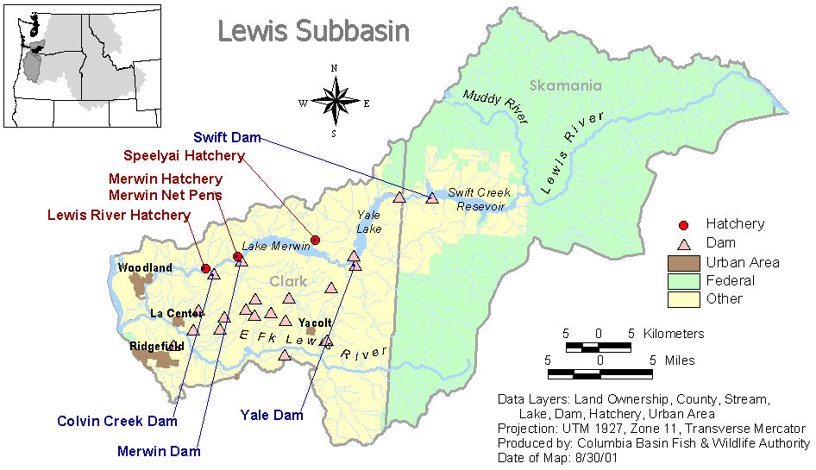

Hatchery Program Reports:

Early Coho
Chambers Hatchery Early Winter Steelhead
Late Coho
Skamania Hatchery Summer Steelhead (North Fork Lewis)
Skamania Hatchery Summer Steelhead (East Fork Lewis)
Skamania Hatchery Winter Steelhead (East Fork Lewis)
Spring Chinook Hatchery
Skamania Hatchery Summer Steelhead

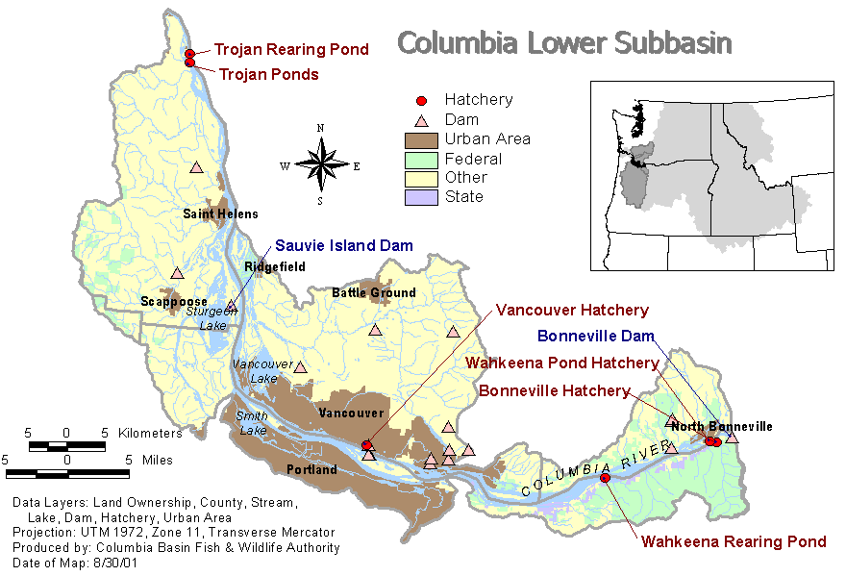
4. Lower Columbia Subbasin

Hatchery Program Reports:

Duncan Creek Integrated Chum
Bonneville Hatchery Coho
Bonneville Hatchery Fall Chinook
Skamania Hatchery Winter Steelhead (Salmon Creek Netpens)

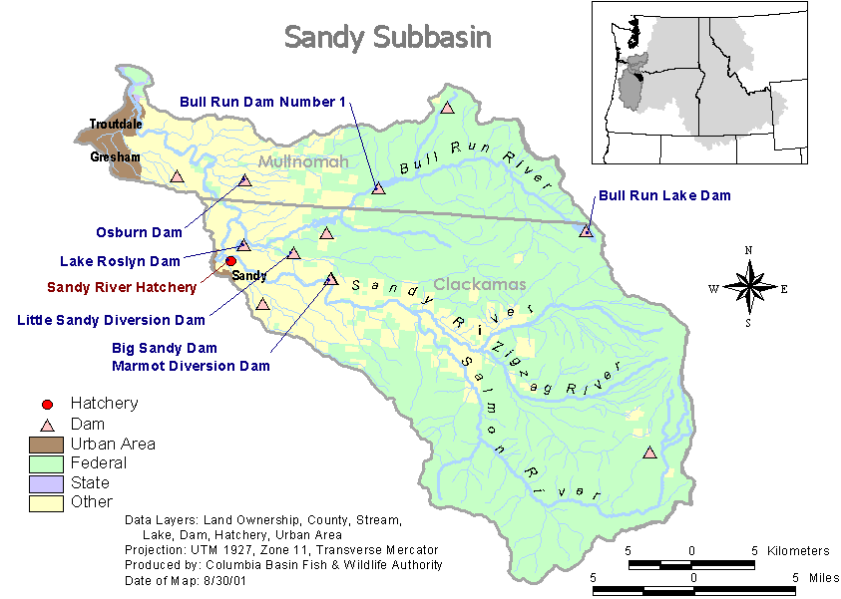
5. Sandy River Subbasin

Hatchery Program Reports:

Coho – Hatchery
Spring Chinook
Skamania Summer Steelhead
Winter Steelhead Integrated

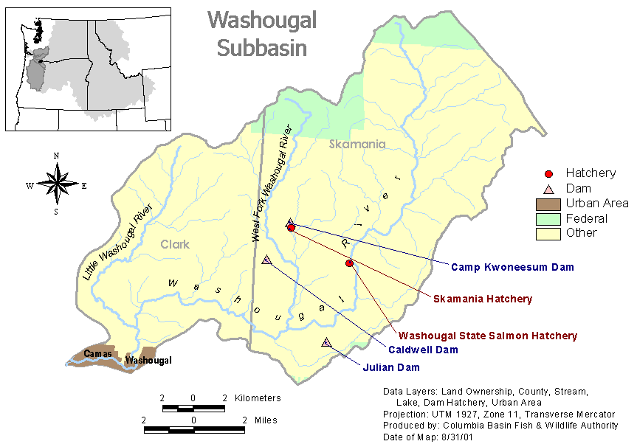
Washougal River Subbasin

Hatchery Program Reports:

Early Winter Steelhead – Hatchery
Fall Chinook
Late Coho
Summer Steelhead

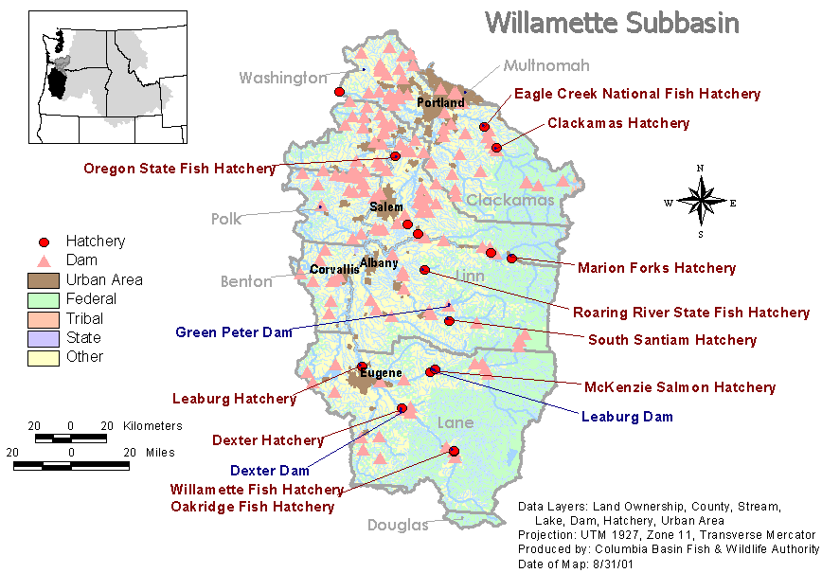
Willamette River Subbasin

Hatchery Program Reports:

Clackamas Hatchery Early Coho
Clackamas Hatchery Early Winter Steelhead
Clackamas Integrated Late Winter Steelhead
Clackamas Integrated Spring Chinook
Clackamas Hatchery Summer Steelhead
McKenzie Integrated Spring Chinook
McKenzie Hatchery Summer Steelhead
Middle Fork Willamette Integrated Spring Chinook
Middle Fork Willamette Hatchery Summer Steelhead
Molalla Integrated Spring Chinook
North Santiam Integrated Spring Chinook
North Santiam Hatchery Summer Steelhead
South Santiam Integrated Spring Chinook
South Santiam Hatchery Summer Steelhead

