VII. Mountain Snake Ecological Province Report

Description
The Mountain Snake Ecological Province consists of tributaries to the Snake River below Hells Canyon Dam that drain from the Rocky Mountains. This includes only two subbasins, the Clearwater and Salmon rivers, although the Salmon River is one of the largest watersheds in the Columbia Basin with several branches and many smaller tributaries. The following subbasins are included in the Mountain Snake Province:
- Clearwater
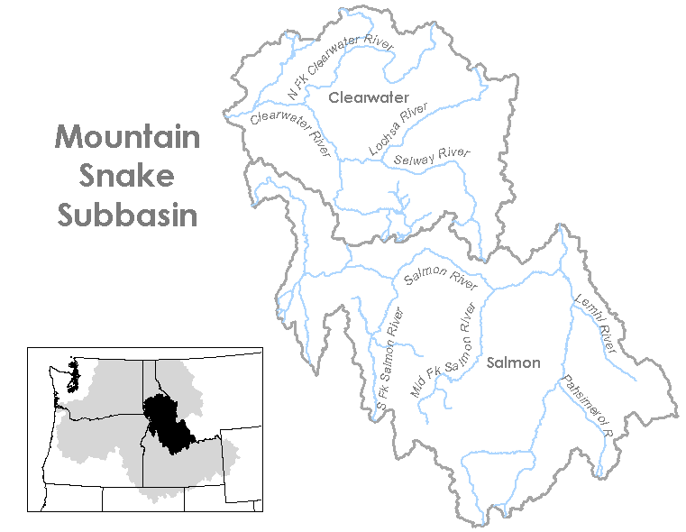
- Salmon
Figure VII-1. Mountain Snake Ecological Province

Results
Figure VII-2. Distribution of fish stocks within the Mountain Snake Province.
Figure VII-3. Distribution of planned releases of anadromous salmonids from hatchery programs in the Mountain Snake Province.
Figure VII-5. Distribution of planned releases of anadromous salmonids from integrated hatchery programs in the Mountain Snake Province.
Figure VII-4. Distribution of planned releases of anadromous salmonids from segregated hatchery programs in the Mountain Snake Province.
Figure VII-6. Stated purpose of anadromous salmonid hatchery programs in the Mountain Snake Province.
Figure VII-7. Funding sources for anadromous salmonid hatchery programs in the Mountain Snake Province.

Subbasin Reports

1. Clearwater Subbasin
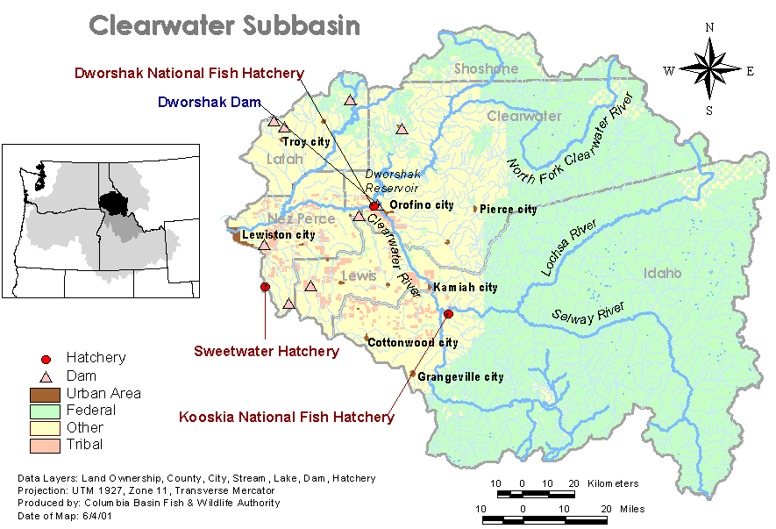

Hatchery Program Reports:

Coho
NP Cherry Lane Integrated Fall Chinook
Big Canyon Integrated Fall Chinook
Clearwater Hatchery Spring Chinook
Dworshak Hatchery Spring Chinook
Kooskia Spring Chinook
Nez Perce Spring Chinook
Clearwater Integrated Summer Steelhead B-Run
Dworshak Integrated Summer Steelhead B-Run
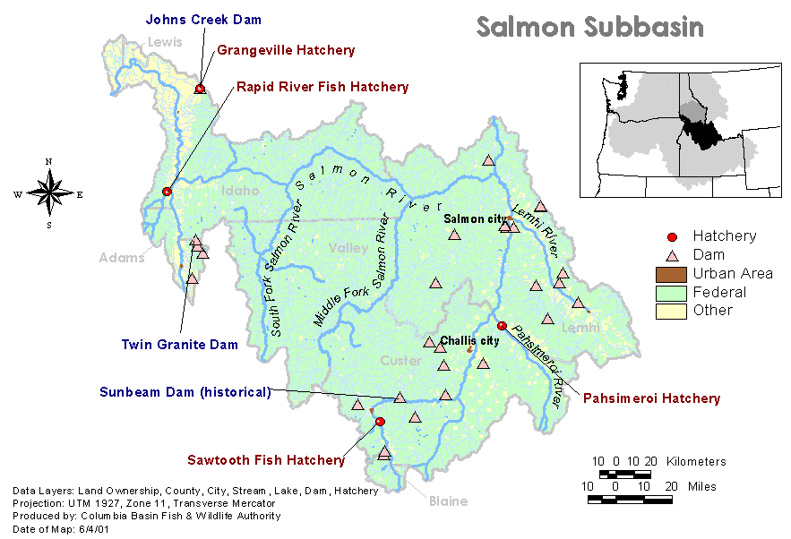
2. Salmon Subbasin

Hatchery Program Reports:

Lemhi River Spring Summer Chinook
Redfish Lake Sockeye
East Fork Salmon River Integrated Spring Summer Chinook
West Fork Yankee Fork Salmon River Integrated Spring Summer Chinook
Upper Salmon Sawtooth Spring Chinook
Rapid River Hatchery Spring Chinook
Pahsimeroi Hatchery Steelhead A-Run
Sawtooth Hatchery Steelhead A-Run
Dworshak Hatchery Steelhead B-Run
East Fork Integrated Steelhead B-Run
Johnson Creek Summer Chinook
Pahsimeroi Summer Chinook
McCall Summer Chinook

