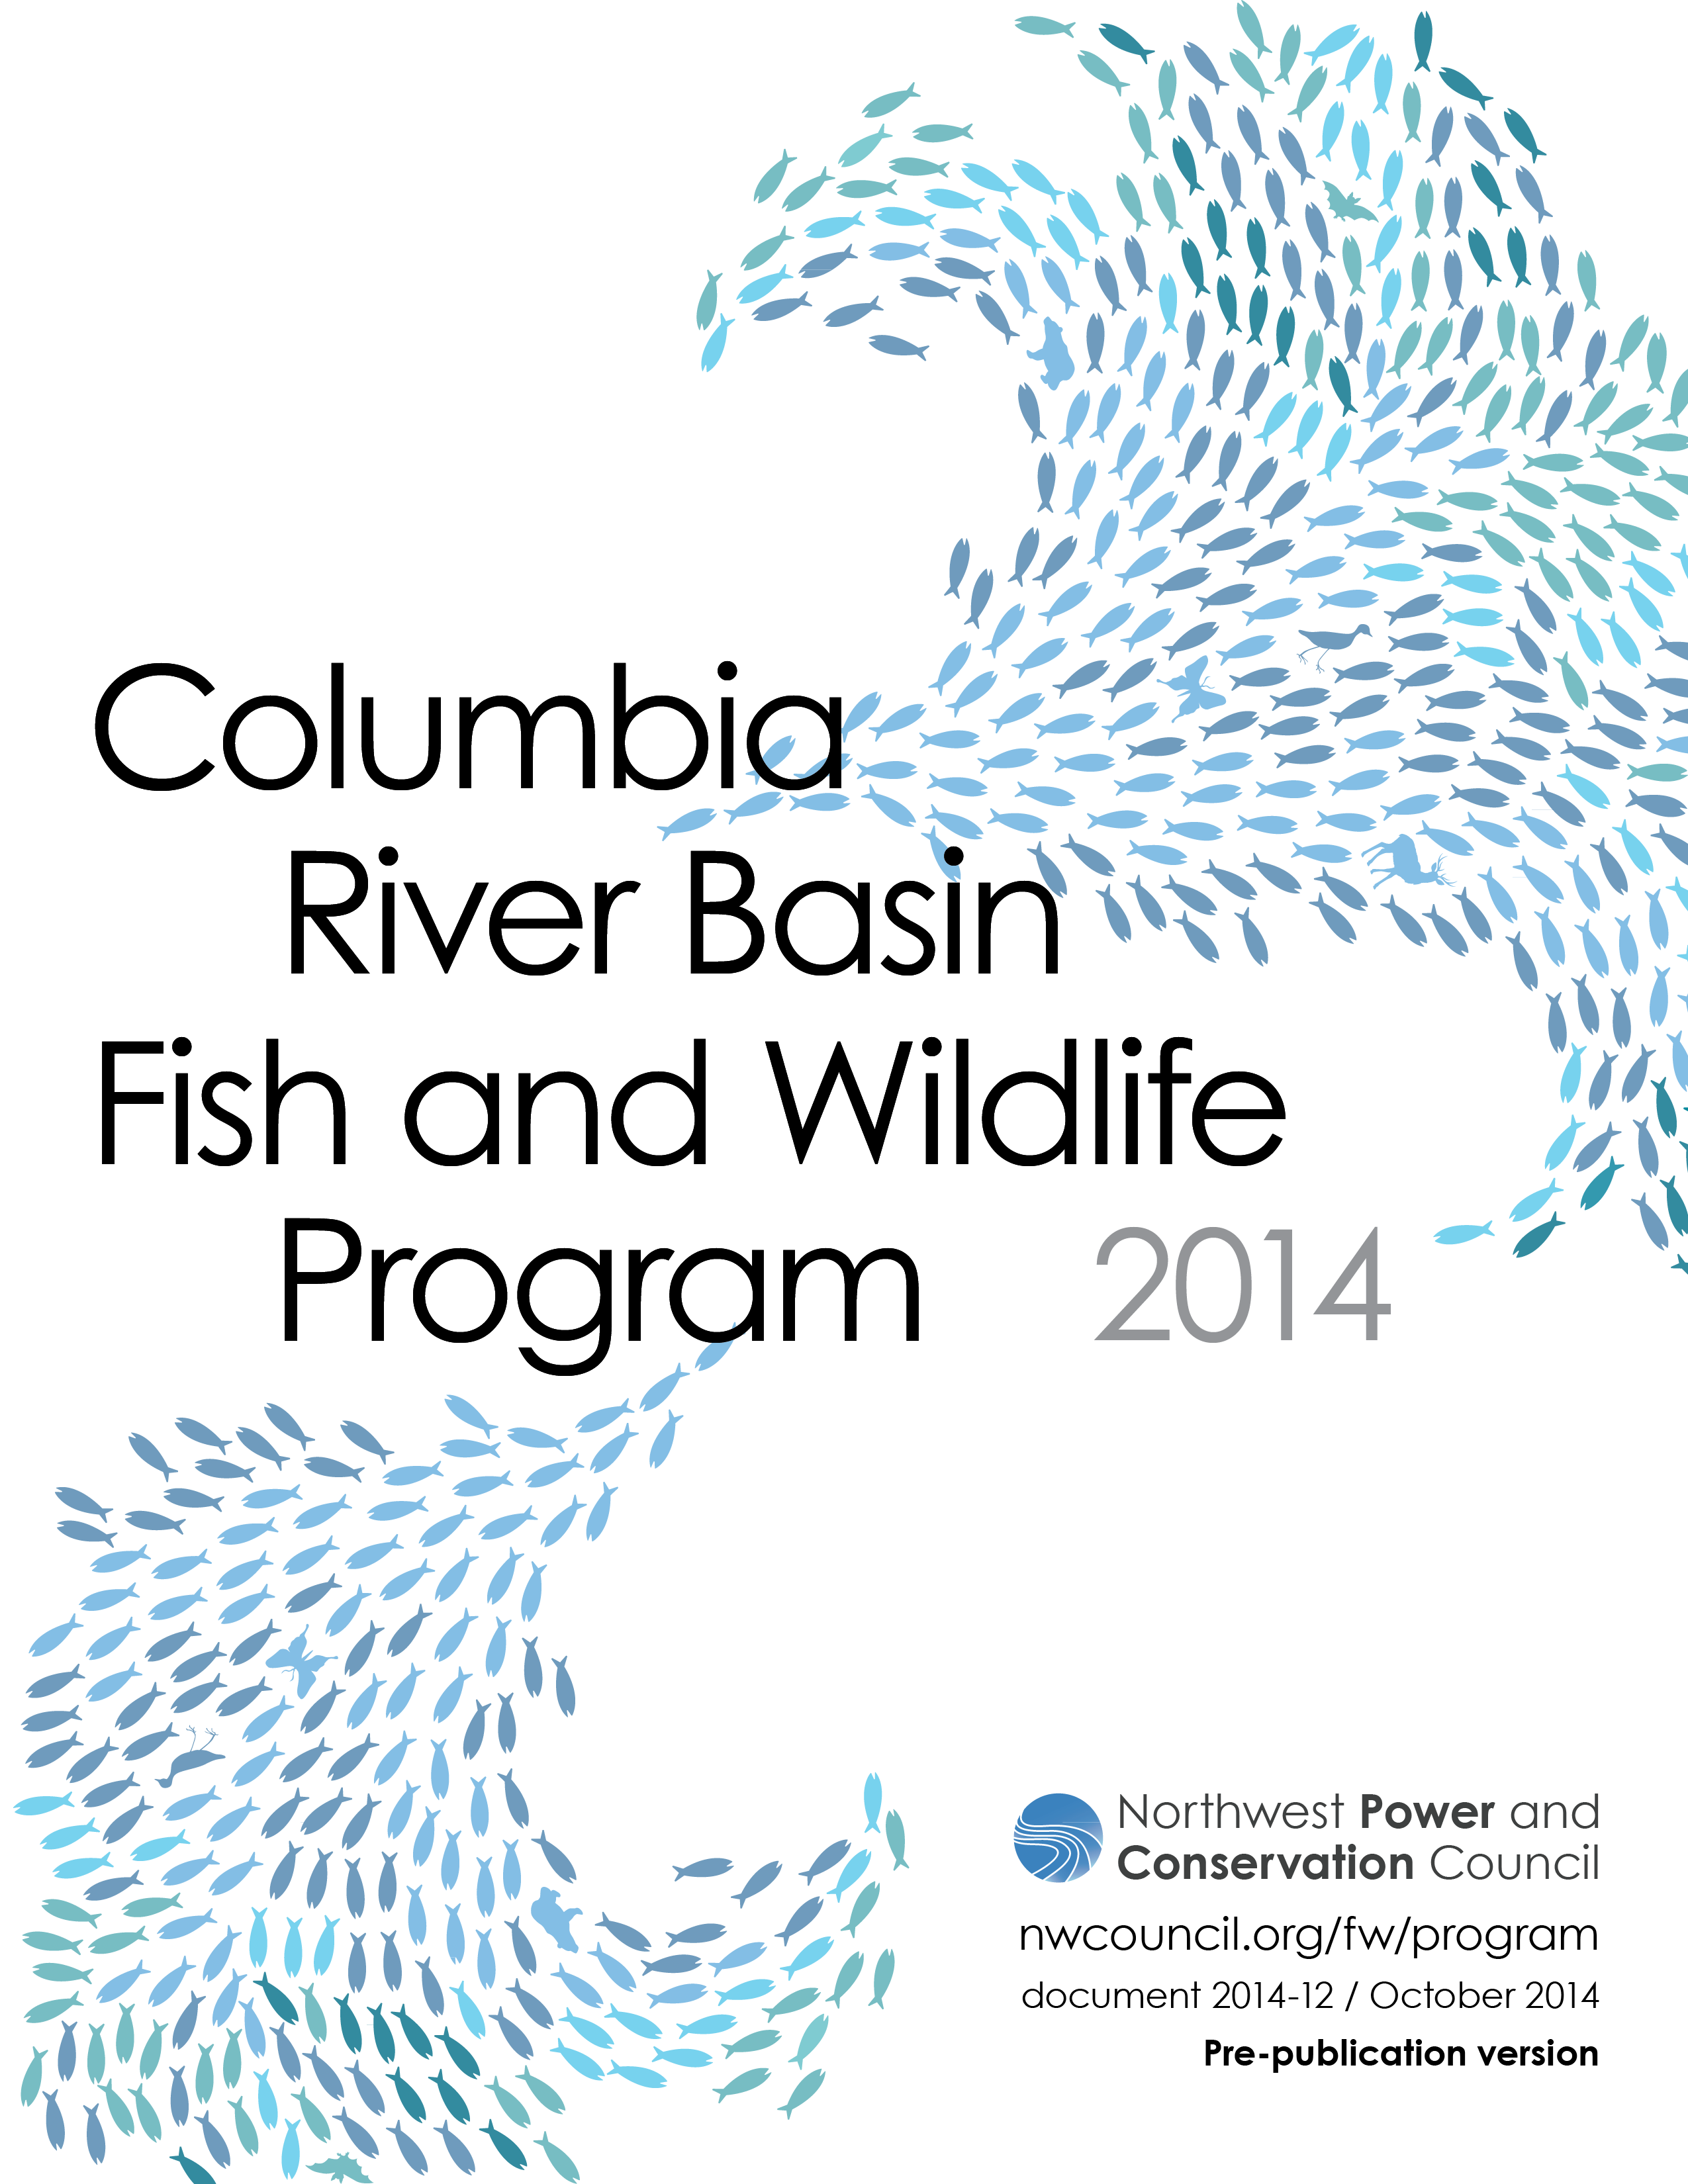**Salmon and Steelhead Program Goals**

**Goal:** Achieve full mitigation for anadromous fish, native resident fish, and wildlife losses by restoring healthy, self-sustaining, and harvestable, natural-origin anadromous fish, especially salmon, steelhead, eulachon, lamprey species, resident fish, including sturgeon and bull trout

**Goal:** Achieve full mitigation for anadromous fish and native resident fish

**Goal:** Encourage biologically diverse species that are resilient to environmental variability

**Goal:** Achieve the delisting and recovery criteria for ESA-listed species in the biological opinions, including for listed salmon and steelhead in NOAA Fisheries’ 2008 FCRPS, Upper Snake and Willamette River biological opinions, and those for listed Kootenai River White Sturgeon, bull trout, and Oregon chub in the U.S. Fish and Wildlife Service’s FCRPS (2000), Libby Dam (2006) and Willamette River (2008) biological opinions.

**Goal:** Achieve anadromous fish inriver migration and passage survival that approximates natural survival during inriver migration

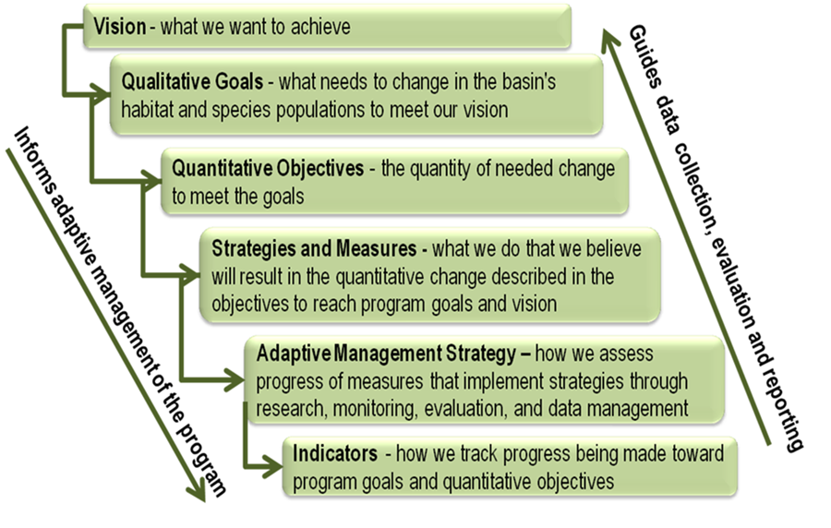For more information on the refinement on goals and objectives within the 2014 Program, see: [www.nwcouncil.org/ 2014ProgramGoals](http://www.nwcouncil.org/%202014ProgramGoals)

To view the existing goals and objectives, see Appendix D of the 2014 Program: [www.nwcouncil.org/  
fw/program/2014-12/program/  
partseven_appendices/d_goals](http://www.nwcouncil.org/fw/program/2014-12/program/partseven_appendices/d_goals/)