Henry Lorenzen  Chair  Oregon | 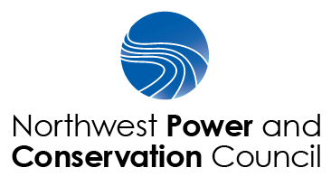 | W. Bill Booth  Vice Chair  Idaho
Bill Bradbury  Oregon  Guy Norman  Washington  Tom Karier  Washington |  | James Yost  Idaho  Pat Smith  Montana  Jennifer Anders  Montana

Regional Coordination Forum – Draft Agenda
December 15, 2016, 9:00 a.m. (Pacific Time) to 4:00 p.m.
Conference line: 1-800-356-8278, code 186685
https://global.gotomeeting.com/join/494956349

9:00 | Welcome and introductions  Purpose & objectives  confirm agenda | F&W Committee Chair Jennifer Anders (on phone) and Member Guy Norman (in person)
9:20  Noon | Topics to discuss below | All
- Cost Savings Workgroup
- Temperature modeling and cold water refuges
- O&M Subgroup activities
- Research Plan
- Blocked Area Mitigation
- Regional Partnership
- NEPA hearings and process
- Status report on quagga mussel prevention and containment work
- Update on the Regional aquatic habitat indictor work (Rhip) – Nancy Leonard

12:00 | Lunch
1:15 | Continuation of discussion topics | All
2:00 | Break
2:15-3:45 | Continuation of discussion and other topics brought forth by attendees  - Regional calendar  - Use of and alignment of various M&E tools in the basin/region (future workshop?)  - other | All
3:45- 4:00 | Wrap up and schedule next meeting | Guy Norman

